
High | High-Density Stadium WLAN  Solution Technical Proposal
High | HUAWEI TECHNOLOGIES CO., LTD.

Copyright © Huawei Technologies Co., Ltd. 2013. All rights reserved.
No part of this document may be reproduced or transmitted in any form or by any means without prior written consent of Huawei Technologies Co., Ltd.

Trademarks and Permissions
and other Huawei trademarks are trademarks of Huawei Technologies Co., Ltd.
All other trademarks and trade names mentioned in this document are the property of their respective holders.

Notice
The purchased products, services and features are stipulated by the contract made between Huawei and the customer. All or part of the products, services and features described in this document may not be within the purchase scope or the usage scope. Unless otherwise specified in the contract, all statements, information, and recommendations in this document are provided "AS IS" without warranties, guarantees or representations of any kind, either express or implied.
The information in this document is subject to change without notice. Every effort has been made in the preparation of this document to ensure accuracy of the contents, but all statements, information, and recommendations in this document do not constitute a warranty of any kind, express or implied.

Huawei Technologies Co., Ltd.
Address: | Huawei Industrial Base  Bantian, Longgang  Shenzhen 518129  People's Republic of China
Website: | http://enterprise.huawei.com
Email: | ChinaEnterprise_TAC@huawei.com
Phone: | 400-822-9999

Contents
1 Stadium Analysis 1
1.1 High Density Scenario Characteristics 1
1.2 Terminal Quantity 1
1.3 User Type 1
1.4 Terminal Type 2
1.5 Applications and Bandwidth 2
2 Solution Design 4
2.1 Overall Network Architecture 4
2.2 WLAN Coverage Design for the Stadium 5
2.3 High Density Access Design 20
2.4 QoS Design 28
2.5 Multicast Service Design 31
2.6 User Authentication and Policy Management 32
2.7 Security Design 36
2.8 Reliability Design 36
2.9 WLAN Management Solution 38

Stadium Analysis

High Density Scenario Characteristics
High-density scenarios are crowded with numerous terminals and users. The user density (the number of users per unit area) in these scenarios is high. All the terminals require access to the network to obtain services.

Terminal Quantity
Based on WLAN construction experience for stadiums, it is estimated that each audience member carries a Wi-Fi smart terminal and 30% smart terminals are in active state or in use after they are connected to the WLAN. The following table provides information about WLAN usage of the stadium.
 | Estimated Percentage | Number of Clients
Maximum capacity | 100% | 28,000
Attendees bringing a Wi-Fi device | 100% | 28,000
Active devices | 30% | 8,400

The data in the table can be adjusted according to actual scenarios.

User Type
Stadium users differ from campus users. Most campus users are fixed office users while users in the stadium are usually mobile visitors. Stadium users include but are not limited to the following:
- Common users
- VIP users
- Staff members
- Media professionals

Terminal Type
Based on stadium user types, possible Wi-Fi terminals are as follows (including but not limited to):
- Smartphone (Android, iOS, Window8, and Blackberry)
- Pad (Android, iOS, and Window8)
- Laptop (MAC OS and WINDOWS)
- Other types of terminals
Wi-Fi terminals currently available on the market support 802.11a/b/g/n standards. If terminals of various standards access the WLAN concurrently, the network rate will be affected.
 | Average Throughput of 10 Users  (Mbps) | Average Throughput of 20 Users  (Mbps) | Average Throughput of 30 Users  (Mbps)
100% HT20 11n | 7.44 | 3.48 | 1.97
75% HT20 11n/25% 11a(g) | 6.84 | 2.88 | 1.67
50% HT20 11n/50% 11a(g) | 6.24 | 2.28 | 1.37
25% HT20 11n/75% 11a(g) | 5.64 | 1.68 | 1.07
100% 11a(g) | 1.86 | 0.87 | 0.49

Applications and Bandwidth
Possible applications that the audience may use include web page browsing, video playing, IM, e-mail, SNS, and VoIP. To provide the required rate and timely services, the bandwidth must meet requirements. Web page browsing is used as an example. To ensure user experience, the delay must be smaller than 4s. The required bandwidth is calculated as follows: Rate = size of a web page/delay = (200 KB x 8)/4 = 400 kbps
              - Typical applications and key indicators
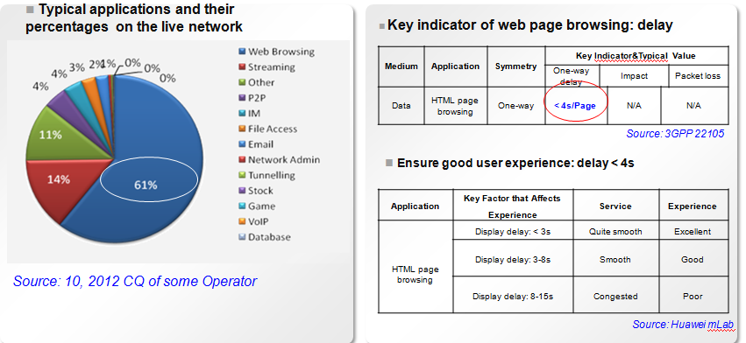

To ensure that applications run properly, the bandwidth must meet the following requirements:
APP | Required Data Rate | Remarks
Web | 160-400 kbps | Size of a web page: 200 KB; delay: 4 to 10s
Video Streaming | 280-560 kbps | Real-time services
IM | 32-64 kbps | 2 KB/Session, 0.5s.
Email | 400 kbps | 100 KB/Session, 2s
SNS | 200 kbps | 50 KB/Session, 2s
VoIP | 256 kbps | Real-time services, for example, 256 kbps GBR for Face Time

The application type and corresponding data in the table can be adjusted according to actual scenarios.

Solution Design

Overall Network Architecture
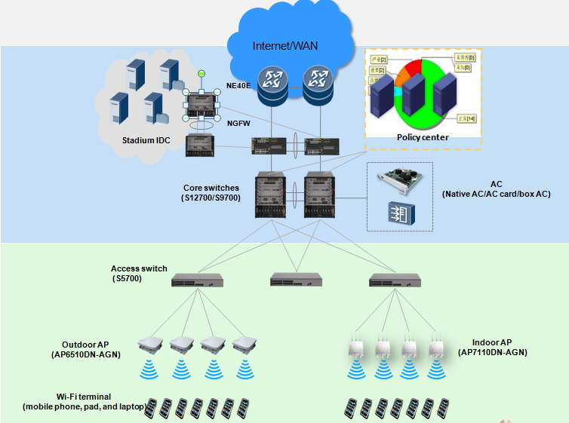

Huawei solution uses a flat network architecture consisting of the access layer and core layer. The core layer is used as the boundary between Layer 2 and Layer 3. The core switches function as the gateways on the entire network.
- Terminal layer
Terminals include Wi-Fi smartphones, tablets, and laptops carried by the audience. Through Wi-Fi hotspots deployed in the stadium, these terminals access the stadium WLAN and obtain Internet services.
- Access point (AP)
The APs provide wireless signals through which the Wi-Fi smart terminals can access the WLAN. Select the AP6510DN-AGN or AP7110DN-AGN for outdoor or indoor scenarios according to the following rules:
- Use indoor APs for indoor corridors, VIP rooms, and lounge areas, and determine the number of APs to be deployed according to user density, area structure, and wall distribution.
- Large stadium terraces are semi-open. Considering the damage caused by rains, dews, or direct sunlight, use outdoor APs in the stadium terrace.
- Access layer
Ethernet switches are deployed at the access layer to connect APs to the stadium network and provide Layer 2 switching functions. Huawei S5700s are used as access switches. The access switches must be able to provide PoE power for APs.
- Core layer
Huawei S12700s/9700s are used as core switches. They are enabled with Layer 3 routing and function as the gateways on the entire network. The ACU2 card is installed on the S9700 to manage APs.
- Access Controller (AC)
You can use box ACs, native ACs (supported on core switches S12700), and AC card as required.
- Network egress
An egress connects users of the stadium network to the public network. The firewall USG6680 is deployed at the egress and connects to the core switch in bypass mode. It provides security guarantee for stadium Internet Data Center (IDC) and Internet access.
- Data center
Servers and application systems are deployed in the IDC to provide internal and external users with data and application services related to the football match. IDC also contains eSight, Policy Center, and service servers, which are respectively used to implement unified network management, authenticate users, and process data services.

WLAN Coverage Design for the Stadium
The WLAN solution for the stadium must meet full coverage and high-density user access requirements. The solution must allow all users to gain access to the WLAN. Interference must be minimized when high-density APs are deployed. To ensure good coverage, APs must be properly deployed and use correct antenna models.
- Outdoor AP selection
Usually, large stadium terraces are semi-open. Rains, dews, and direct sunlight may cause damage to APs; therefore, outdoor APs are recommended. At the terrace, if the AP is near the access switch (the distance between them is smaller than 80 m), use the AP6510DN (PoE power supply is supported); if the AP is far from the access switch and the switch cannot provide power for the APs, use the AP6610DN that supports local AC power supply. The AP6610DN can also connect to the optical interface of the access switch.
              - Comparisons between Huawei AP6510DN and AP6610DN
Huawei AP Model | AP6510DN | AP6610DN
Appearance | 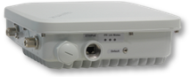
High-Density Mode Supported (Y/N) | Y | Y
MIMO | 2x2 | 2x2
Number of Concurrent Users Supported | 60 | 60
Maximum Number of Users Supported | 128 | 128
Antenna Type | External antenna | External antenna
Maximum Transmit Power for Each Antenna | 26 (2 GHz) + 20 (5 GHz) dBm* | 27 (2 GHz) + 24 (5 GHz) dBm*
Power Consumption | 25.5 W | 30 W
Power Supply Mode | PoE: -48 V DC | Local AC power supply
Working Mode | Fit/Fat | Fit/Fat
Operating Temperature | -40 to 60°C | -40 to 60°C
Wi-Fi Standard | a/b/g/n | a/b/g/n
Uplink Interface | ETH: 10/100/1000M | SFP or ETH
Protection Grade | IP67 | IP67

The maximum transmit power of the antenna varies according to countries.
- AP deployment mode
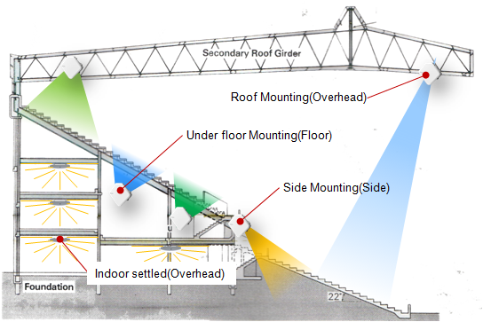

APs can be deployed in three modes: overhead, side, and floor, as shown in the preceding figure. The three modes can be flexibly selected according to service requirements.
              - AP deployment in overhead mode (top view)
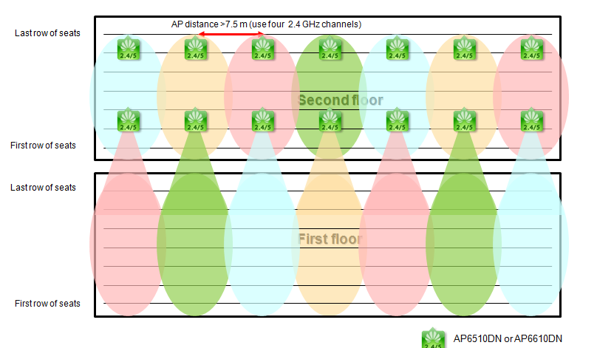

              - AP deployment in overhead mode (profile view)
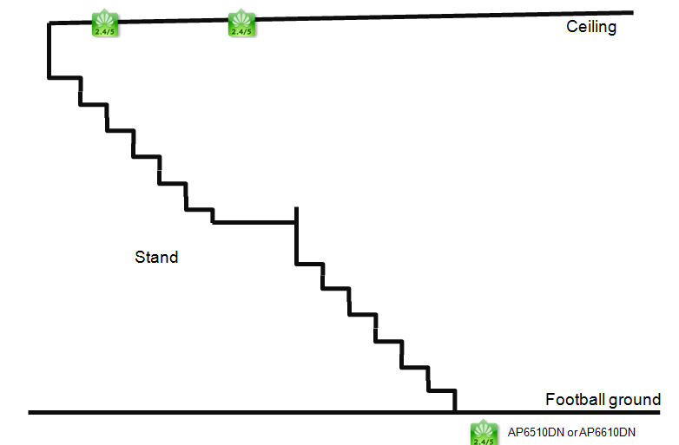

              - Coverage areas of APs in overhead mode
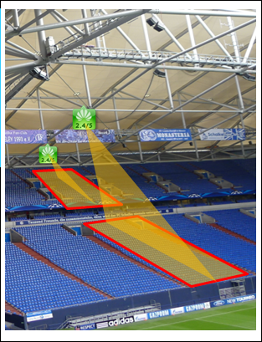

In overhead mode, APs are deployed above the coverage areas, such as the ceiling of the stadium. APs are hidden and installed at a high position. This deployment mode provides high security and prevents APs against intentional damage and theft. Since APs provide signal coverage in line-of-sight (LoS) distance, this mode causes no penetration loss and provides a good coverage effect. However, APs deployed in overhead mode are prone to interference, especially when they use antennas providing a poor radiation angel control capability. Moreover, this mode poses high requirements on construction conditions, such as the bearing capability of the ceiling. The height work cost is also high.
              - AP deployment in side mode (top view)
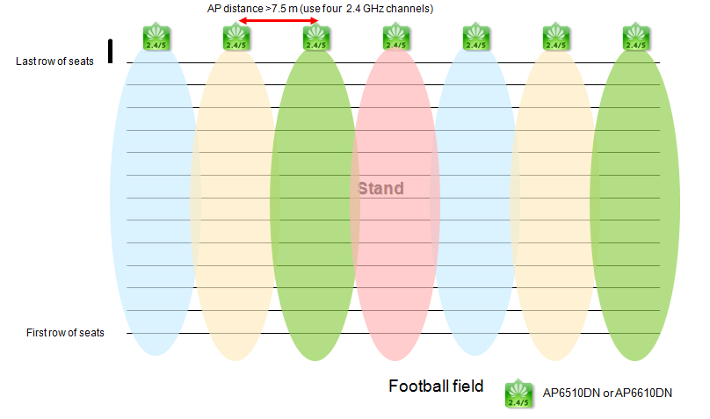

              - AP deployment in side mode (profile view)
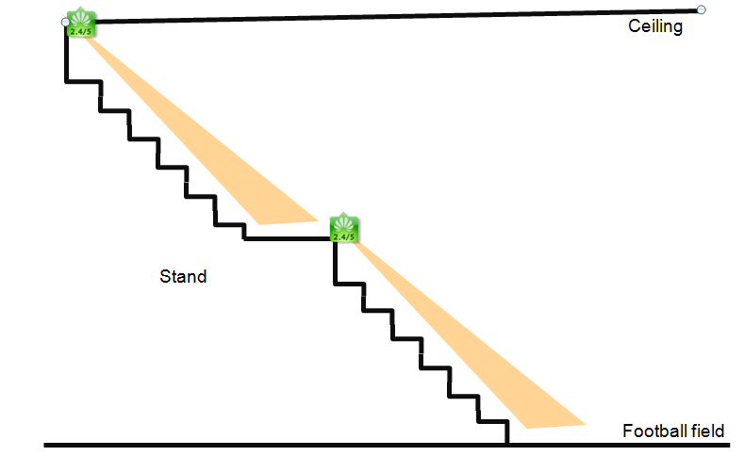

              - AP deployment in side mode
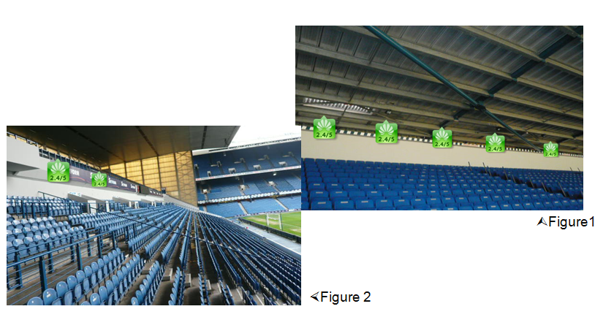

In side mode, APs are side-mounting to billboards, poles, or walls. This mode is easy to implement and provides a good coverage effect. APs deployed in side mode provide signal coverage in LoS distance; therefore, they cause serious interference to each other, especially when they use antennas of which radiation angle is difficult to control.
              - AP deployment in floor mode (profile view)
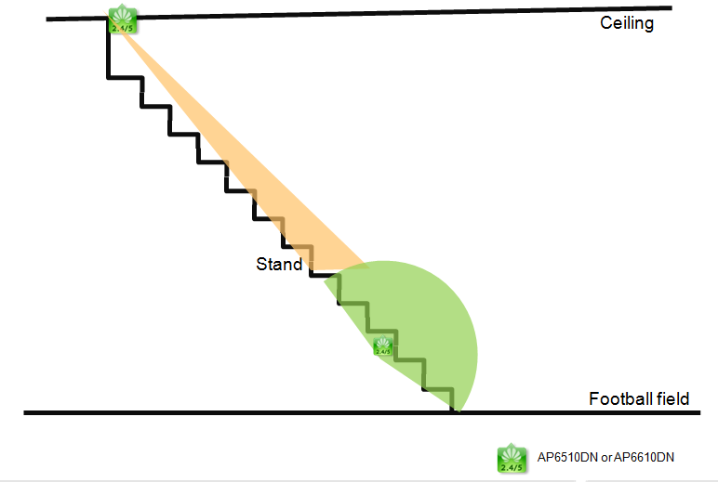

              - AP deployment in floor mode (at the rear of the stand)
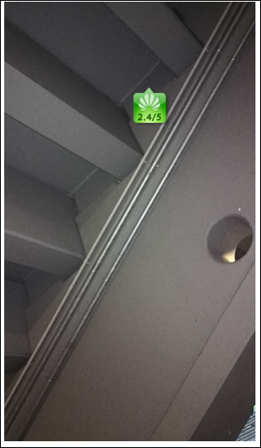

              - AP deployment in floor mode (under seats)
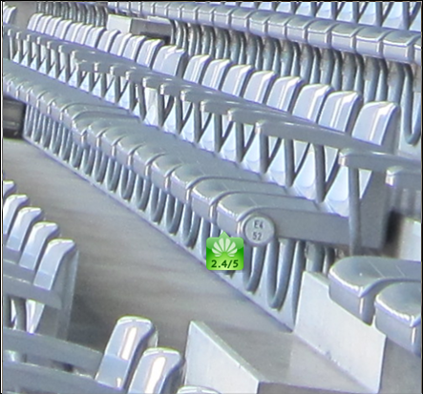

The floor mode uses a cellular coverage design. APs are installed under seats or at the rear of the stand. This mode makes good use of the seats, stands, and audience to isolate APs from each other. In this way, APs cause a little interference to each other and channels can be multiplexed. Densely deployed APs can connect more users. However, project implementation in this mode is difficult. Laying steel tubes or installing AP protection boxes may cause damage to the building surface.
When APs are deployed at the rear of the stand, use indoor APs if the signal attenuation caused by cement panels is small. If the cement panels cause serious signal attenuation, use outdoor APs with directional antennas vertical to the stand. Carry out corresponding tests to verify the signal attenuation and coverage effect.
                - AP deployment mode comparisons
Coverage Mode | Advantage | Disadvantage | Recommends
Side | - APs and terminals are visible to each other in line-of-sight distance, with penetration loss within the allowed range.  - The APs are easy to install.  - APs are placed in a line. Co-channel APs are far from each other, providing good anti-interference capability. | - The last row of seats is near the ceiling. APs are within reach of the audience. In this situation, AP protection boxes are required.  - If the terrace has a large stand depth, customers need to deploy APs in other modes to enhance signal coverage. | «««««
Overhead | - APs are easy to install on ceilings with bridleways.  - APs and terminals are visible to each other in line-of-sight distance, with penetration loss within the allowed range. | - It is difficult to install APs on high ceilings with simple structure.  - Channel planning must take all APs around into consideration. This mode has poor anti-interference capability. | ««««
Floor | - AP signals attenuate due to obstacles. The AP coverage area can be controlled. Therefore, many APs can be deployed to connect more users.  - APs are deployed at the rear of the terrace, invisible to the audience. | Obstacles between the terrace and terminals are complex; therefore, signal attenuation is hard to estimate. | «««

- Antennas with a small beam angle
Interference among APs deployed in high density scenarios is more serious than APs deployed in common scenarios; therefore, it is very important to control AP's coverage areas in high density scenarios. When selecting antennas, you must select those whose signals transmit only within the target coverage areas but get fast attenuated in other areas. In a stadium, it is difficult to deploy APs in close proximity, so a directional antenna with a small beam angle is the optimal choice. This type of antennas is commonly used in high density scenarios.
              - Huawei small-angel antenna used in high-density scenarios
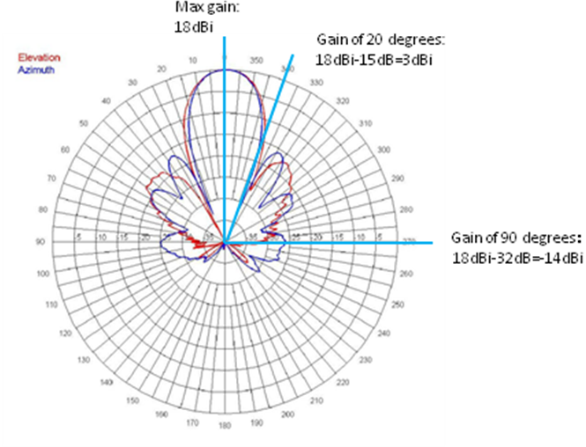

As shown in the preceding figure, horizontal and vertical beam angels of the antenna are all 18°. The blue pattern shows antenna radiation in the horizontal direction and the red shows antenna radiation in vertical direction. A good angel control capability allows the antenna gain to decrease to 3 dBi or below in coverage areas 20° deviating from the main lobe and decrease to -14 dBi in coverage areas 90° from the main lobe.
Huawei provides several models of antennas with small beam angle. These antennas have good radiation angel control capability and can control AP coverage radius within the effective range to reduce interference.
                - Huawei antenna comparisons
 | 18° (2.4 GHz) | 15° (5 GHz) | 60° (2.4 GHz) | 60° (5 GHz)
Appearance |  | 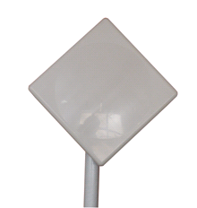 |  | 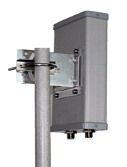
Number of Antennas Required by Each AP | 1 | 1 | 1 | 1
Applicable Frequency | 2.4 GHz | 5 GHz | 2.4 GHz | 5 GHz
Gain (dBi) | 18 * | 19 * | 11.5 * | 12 *
Horizontal Lobe | 18° | 15° | 60° | 60°
Vertical Lobe | 18° | 15° | 30° | 30°
Polarization Mode | Dual-polarized | Dual-polarized | Dual-polarized | Dual-polarized
Interface | N-female*2 | N-female*2 | N-female*2 | N-female*2
Applicable APs | AP6510DN  AP6610DN | AP6510DN  AP6610DN | AP6510DN  AP6610DN | AP6510DN  AP6610DN
Dimension (mm) | 340 x 340 x 25 | 250 x 250 x 25 | 250 x 155 x 60 | 230 x 145 x 55
Part Number | 27011344 | 27010890 | 27010812 | 27010889

Attenuators need to be configured to meet safety certification requirements of different countries.
If antennas with a horizontal lobe angle of 18 degrees are installed on an H-meter (for example, 40-meter) ceiling, facing the stand, the beams of the antennas are as follows:
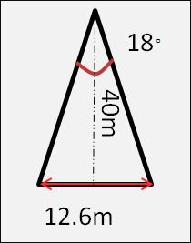

As shown in the figure, antennas with small beam angel have a small coverage radius, which can effectively control the AP coverage areas. Therefore, the number of APs to be deployed can be increased to connect more users.
- Interference management
In addition to basic coverage designs, well-designed frequency bands and deployment of interference management features are also necessary to further reduce WLAN interference.
              - Frequency band design for the stadium
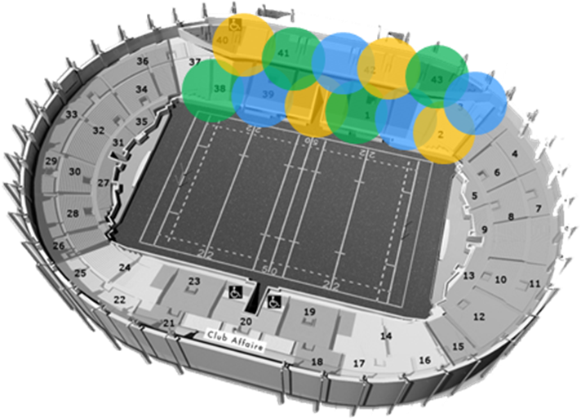

Both 2.4 GHz and 5 GHz radio resources are limited. A cellular channel distribution mode is used in stadium WLAN coverage projects to ensure that channels can be multiplexed, without overlapping areas. When many APs are densely deployed, arrange APs on the channels 1, 9, 5, 13 in sequence to reduce co-channel interference.
WLAN interference includes internal interference and external interference. Internal interference can be eliminated through proper frequency planning, AP deployment, and antenna selection. Huawei solves external interference problems through spectrum analysis.
              - Spectrum analysis
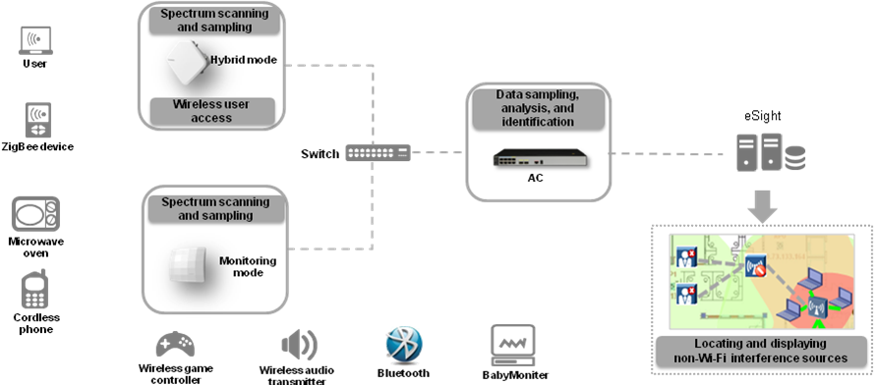

Huawei spectrum analysis solution uses special APs working in monitor mode or service APs working in hybrid mode to scan and sample the spectrum of non-Wi-Fi interference sources, such as microwave ovens and cordless phones. These APs report their collected or sampled data to the AC. The AC then analyzes the data and identifies the interference source type. Huawei network management system eSight can display the locations of interference sources, which are visually presented to maintenance personnel, helping them troubleshoot and remove the interference sources in an easy manner.
- Access switch planning
            - Ensure that the cable length from the access switch to APs does not exceed 80 meters. If cables with high transmission capability are used, such as the CAT5E cables, the maximum cable length can be 100 meters (the cable length is not direct distance between the switch and APs, but calculated based on cabling rules).
            - Avoid heavy magnetic and electronic interferences on the sites where access switches are installed.
            - Ensure that reliable AC power supply is available on the sites where the access switches are installed.
            - Protect the switches from moisture and dust (purchase protection boxes according to environment situations).
            - Determine the number of access APs based on the number of switch interfaces, PoE power supply capability of the power module, and AP power consumption (note that outdoor APs have high power consumption).
- Cabling rules and power supply
            - Ensure that the cable length from the AP to the access switch does not exceed 80 meters. If cables with high transmission capability are used, such as the CAT5E cables, the maximum cable length can be 100 meters
            - Reserve 5-meter length for cable adjustment.
            - Keep the network cables far away from electromagnetic field.
            - Obtain the customer's and property owner's approval on the cabling routes.
              - AP power supply mode
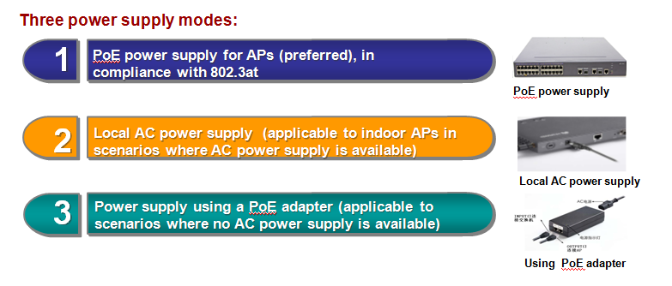

            - APs deployed in overhead mode are far from the cabinet. In such as case, extend the feeder line length. Install the antennas on the ceiling and place APs in a low position.
                - Receive sensitivity of mobile phones and APs
Device | Transmit Power | Antenna Gain | Receive Sensitivity (2.4 GHz, 802.11n, HT20, and MCS7/15)
AP | 27 dBm | Depends on the antenna. | -71 dBm
Mobile phone | 10-13.8 dBm | 0 dBi | -64 dBm

The table provides typical values. Actual values may vary according to vendors.
The formula to calculate the uplink signal strength is as follows (regardless of factors such as interference, line loss, and attenuation caused by obstacles):
Signal strength = Transmit power + Transmit antenna gain – Transmission attenuation + Receive antenna gain
In the preceding formula, the difference between the signal strength and system power margin must be larger than the receive sensitivity of the device.
The system power margin depends on the signal transmission environment, and is usually taken as 10 dB.
The relationship between the signal attenuation and transmission distance is as follows:
Distance | 1 m | 2 m | 5 m | 10 m | 20 m | 40 m | 80 m | 100 m
Signal attenuation | 39.6 dB | 45.62 dB | 54.02 dB | 60.04 dB | 66.06 dB | 72.08 dB | 79 dB | 80.04 dB

For example, if the ceiling is 40-meter high, the signal attenuates by 72.08 dB. In this case, use antennas with a gain of 18 dBi.
The uplink signal strength is -40.28 dBm (13.8-72.08+18=-40.28 dBm). The AP receive sensitivity is -71 dB, which is smaller than -50.28 dB (-40.28dBm – 10 dB = -50.28 dB), allowing 20.72 dB feeder line loss. Attenuation of different antenna models varies. Calculate the maximum feeder line length based on the selected antenna model. The table provides only theoretical data. In actual scenarios, calculate the feeder line length based on actual test data.
- SSID Planning
Service set IDs (SSIDs) are divided based on user types or service types on the stadium wireless network. SSIDs are planned as follows:
User Type | Access Network | Terminal Device | SSID
Common users | Internet and stadium's external service network | Laptop/Pad/Smartphone | SSID-Plain
VIP users | Internet and stadium's external service network | Laptop/Pad/Smartphone | SSID-Vip
Media professionals | Internet and stadium's external service network | Laptop/Pad/Smartphone | SSID-Vip
Staff members | Internet and stadium's external service network | Laptop/Pad/Smartphone/Special Terminal | SSID-staff

In general, management VLANs and service VLANs are isolated on the Ethernet. Service VLANs identify services and users.
On WLANs, SSIDs also identify services and users. Therefore, you need to take mappings between VLANs and SSIDs into consideration when planning the service VLANs. The number of service VLANs and number of SSIDs should be in the ratio of 1:1, 1:N, N:1, or N:N based on service requirements. Service VLAN IDs are terminated on ACs.
An AP can be configured with multiple SSIDs. Huawei single-frequency AP supports 16 SSIDs, and dual-frequency AP supports 32 SSIDs. You can divide an AP into multiple virtual access points (VAPs) and each SSID corresponds to one VAP. The AC delivers policies based on VAPs and the VAP manages terminals and services based on policies.

High Density Access Design
The stadium requires high-density access. Huawei stadium solution provides rich software features to manage radio resources and improve high-density access performance.
These features include interference suppression, air interface resource scheduling, multi-user scheduling, and load balancing.
Type | Description | Benefit
Interference suppression | CCA optimization | CCA optimization improves the AP's anti-interference capability.
Interference suppression | Packet-based Power Control (PPC) | Downlink power control of APs reduces internal interference.
Interference suppression | Automatic radio calibration | The AP monitors network environment changes, and implements radio calibration periodically or triggers radio calibration by event to remain the optimal network performance.
Air interface resource scheduling | Access control on low-rate and weak-signal users | The AP restricts access of low-rate and weak-signal users to improve air interface usage efficiency.
Air interface resource scheduling | Forced logout of low-rate and weak-signal users | The AP forces low-rate and weak-signal users to log out to improve air interface usage efficiency.
Air interface resource scheduling | Implicit and explicit Beamforming | Beamforming technology improves air interface usage efficiency and ensures user experience.
Multi-user scheduling | Dynamic EDCA parameter adjustment | APs flexibly adjust Enhanced Distributed Channel Access (EDCA) parameters to reduce the possibility of collision, improve the throughput, and increase the number of access users.
Multi-user scheduling | Virtual channel scheduling (VAP) | STAs are distributed to different virtual channels, which reduces the possibility of collisions, improves the throughput, and increase the number of access users.
Multi-user scheduling | Fair scheduling | Downlink scheduling allocates equal time to users of different rates, helping high-rate users transmit more data and obtain high user experience.
Load balancing | 5G-prior access | Dual-band terminals preferentially access the 5 GHz radio to make full use of 5 GHz channel resources. This distributes terminals evenly, improving user access experience.
Load balancing | Load balancing | Terminals are evenly distributed among APs, which improves user access experience.

- Interference Suppression
- CCA optimization
CCA, short for Clear Channel Assessment, allows an AP or STA on the WLAN to detect channel energy to check whether the channel is idle.
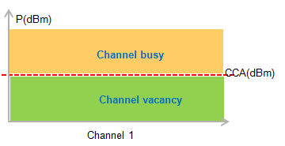

            - When the energy of a channel is larger than or equal to the CCA threshold, the channel is considered busy and packets are not sent over this channel.
            - When the energy of a channel is smaller than the CCA threshold, the channel is considered idle and used to send packets.
In high density scenarios, many APs and STAs exist and are near to each other. The signal strength is strong, so the detected energy easily exceeds the CCA threshold and two or more devices may share the bandwidth. Huawei CCA optimization reduces the possibility of bandwidth shared by multiple devices, allows more user access, and improves the throughput.
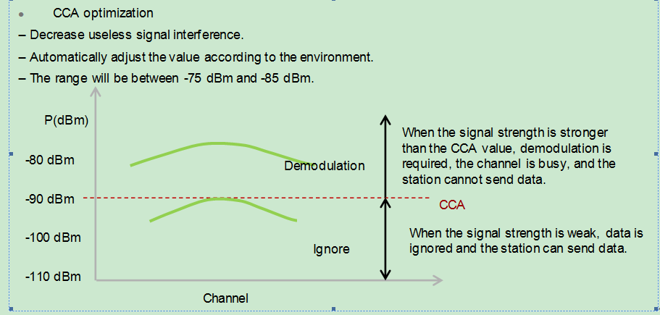

- Packet-based Power Control (PPC)
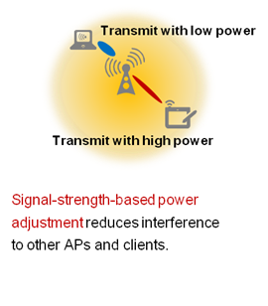

PPC effectively reduces internal interference and improves the throughput. It enables an AP to detect the signal strength of a STA in real time. If the AP detects that the signal strength of the STA is strong (the STA is near the AP), the AP reduces its transmit power when sending packets. If the AP detects that the signal strength of the STA is weak (the STA is far from the AP), the AP uses the normal transmit power to send radio signals.
- Automatic radio calibration
Automatic radio calibration allows an AP to collect signal strength and channel parameters of surrounding APs and generate AP topology according to the collected data. Based on interference from authorized APs, rogue APs, and non-Wi-Fi interference sources, each AP automatically adjusts its transmit power and working channel so that the AP can work at optimal performance. In this way, network reliability and user experience are improved.
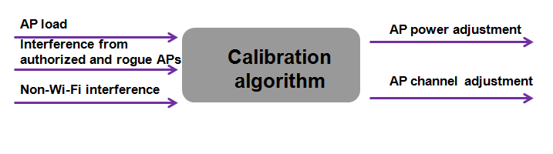

- The AP transmit power obtained through automatic radio calibration determines the upper threshold of AP actual transmit power. PPC adjusts AP transmit power per packet within the upper limit.
- Automatic radio calibration reduces network maintenance workload and keeps the AP in the optimal performance. However, radio calibration may affect services. Exercise caution when using it in high-density scenarios where the service volume is large.
- Radio calibration is implemented based on ACs. Each AC is a radio calibration region. In each radio calibration region, the AC determines the minimum radio calibration range based on the signal strength and reduces the calculation work to ensure a good calibration effect.
- Air interface resource scheduling
Access of low-rate STAs seriously reduces efficiency of the air interface and affects user experience in high density scenarios, access of many low-rate STAs consumes many resources on the air interface, reduces the AP capacity, and lowers user experience. Controlling access and usage of low-rate STAs can reduce the impact.
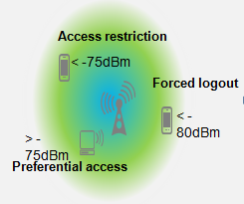

            - Restrict access from low-rate STAs.
An AP checks the access rate of STAs and rejects access of low-rate STAs.
            - Restrict access from weak-signal STAs.
An AP checks the signal strength of STAs and rejects access of weak-signal STAs.
            - Force logout of low-rate STAs.
An AP monitors the rate of online STAs in real time and forces low-rate STAs to log out so that the STAs can reassociate with APs with strong signals.
            - Force logout of weak-signal STAs.
An AP monitors the signal strength of online STAs in real time and forces weak-signal STAs to log out so that the STAs can reassociate with APs with strong signals.
            - Beamforming
Beamforming allows the transmitter to adjust transmitting parameters based on the obtained channel information to achieve energy concentration on the receiving end. This enhances signal coverage and increases AP capacity. Huawei stadium solution supports implicit and explicit Beamforming, which can improve link performance of all terminals and the air interface usage efficiency.
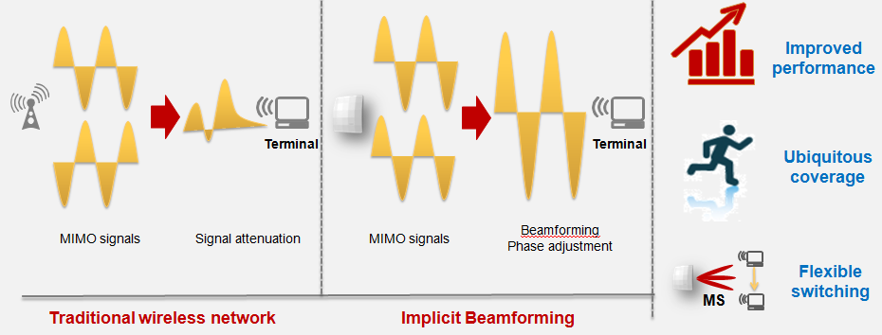

- Multi-user scheduling
- Dynamic EDCA parameter adjustment
WLAN provides competition-based multi-address access services. If a large number of users exist, the possibility of collisions increases. When an increasing number of users connect to an AP, AP throughput reduces sharply. This may lower the quality of user experience. EDCA defined by 802.11e allocates different priorities to services of different types by setting different access parameters. Different settings of access parameters affect the possibility of collisions. Huawei dynamic EDCA can detect the user quantity on each AP and flexibly adjust EDCA parameters, which reduces the possibility of collisions, improves AP capacity, and enhances user experience. According to Tolly reports, Huawei AP throughput is 11% higher than Cisco products in a single-user scenario and is 16% higher than Cisco products in a multi-user scenario. Dynamic EDCA is supported by all Huawei indoor and outdoor APs used in high-density scenarios.
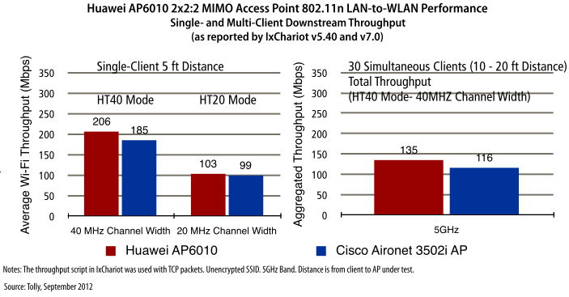

- Airtime scheduling
The same packet transmitted by STAs at different rates requires different time on the air interface. A high-rate STA has strong transmission capability and high spectrum efficiency, so less time is taken to send packets on the air interface. A low-rate has low transmission capability and low spectrum efficiency, so much time is taken to send packets on the air interface. This reduces the throughput of each AP and lowers the system efficiency. Airtime scheduling evenly allocates the downlink transmission time and helps high-rate STAs transmit more data, improving the AP throughput and allowing more user access.
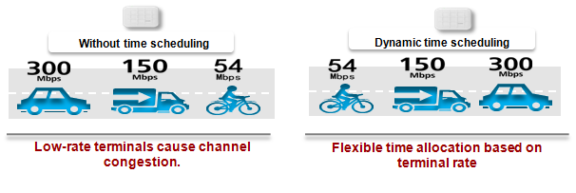

- Multi-lane scheduling
When more users exist on the WLAN based on competition mechanism, there is higher probability of collisions and system efficiency is greatly reduced. In the stadium scenarios, there are many users. The collisions will affect access performance of each AP. Multi-lane scheduling allows STAs of APs to be distributed into different virtual channels to reduce the collisions. In traditional scheduling, 12 STAs preempt the channel of the air interface simultaneously. In Multi-lane scheduling, 12 STAs are distributed into three virtual channels. That is, four users preempt the channel of the air interface simultaneously. Multi-lane scheduling reduces the possibility of collisions and improves user access performance in high-density scenarios.
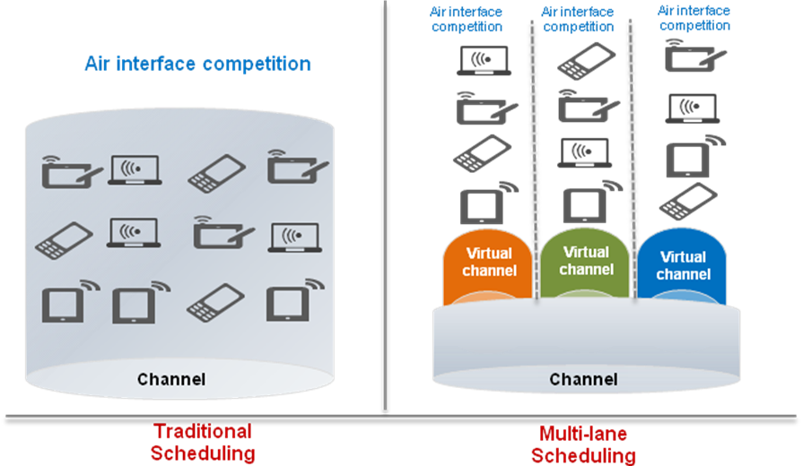

- Load balancing
- 5G-prior access
STAs often use 2.4 GHz radio. As a result, the 2.4 GHz frequency band with fewer channels is congested, and has a high load and strong interference. The 5 GHz frequency band with more channels and less interference is not fully used. When an AP and STA support both 5 GHz and 2.4 GHz frequency bands, the AP can request the STA to associate with the 5 GHz radio first. 5G-prior access reduces load pressure and interference on the 2.4 GHz radio and improves user experience. 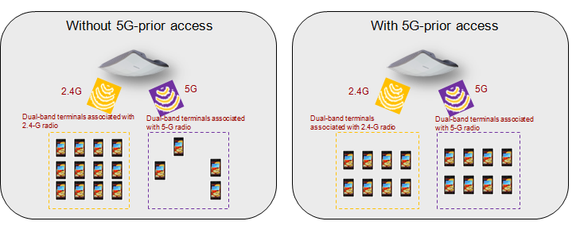

The implementation of this feature is restricted by the percentage of dual-band terminals on the live network. Some chip vendors predict that the number of delivered dual-band terminals will account to 50% of the total delivery by the end of 2014. In fact, according to statistics on mainstream smart terminals on the market, the percentage of dual-band terminals has already exceeded 50%.
Model | WIFI Protocol Supported | 5 GHz Frequency Band
Samsung GALAXY S4 | 802.11 a/n/b/g/ac | Supported
Apple IPHONE5 | 802.11a/b/g/n | Supported
HTC one | 802.11 a/ac/b/g/n | Supported
Sony Xperia Z | 802.11 a/b/g/n | Supported
GALAXY SIII | 802.11 a/b/g/n | Supported
iPhone4S | 802.11b/g/n | Not supported
BlackBerry Z10 | 802.11 a/b/g/n | Supported
LG Nexus 4 | a/b/g/n | Supported
Nokia Lumia920 | 802.11 a/b/g/n | Supported
BlackBerry Q10 | 802.11 a/b/g/n | Supported

- Load balancing
Due to difference in terminal use habits, one of the two neighboring APs may be heavily loaded while the other may have a light load. Load balancing distributes users to lightly-loaded APs based on user quantity and traffic volume on the APs. In this way, traffic load is balanced among APs to prevent an AP from being heavily loaded.
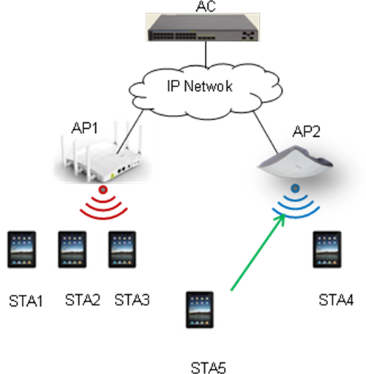

QoS Design
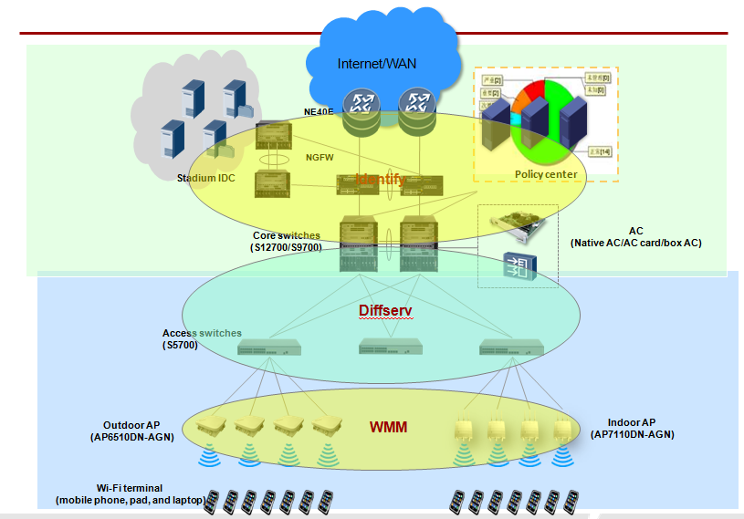

In addition to traditional data services such as web, email, and FTP services, stadium service platform transmits services such as VoD, video advertisement pushing, and voice services, which have specific requirements for bandwidth, delay, and delay variation. For example, the VoD service requires high bandwidth, short delay, and low jitter. The voice service does not require high bandwidth, but requires short delay. When congestion occurs, the voice service must be processed first.
To meet requirements of different applications for the bandwidth, delay, and jitter, stadium projects use DiffServ to ensure transmission of high-priority services. The DiffServ model is a multi-service model. In the DiffServ model, network devices provide services for each packet based on the precedence field in the packet such as 802.1p and DSCP priorities. The DiffServ model applies the same service policy to packets of the same type, without using any signaling protocols.
The AC controls bandwidth for uplink traffic sent from user terminals to servers. Because the downlink traffic contains video traffic, applications need to be identified and bandwidth needs to be ensured. Data center switches identify multicast groups and the firewall identifies services, and the DiffServ model is used at the wired side and VMM is used at the wireless side, to ensure user experience of high-priority services.
Video service is used as an example. The service process is as follows:
            - Smart terminals (smart phones and tablets) are authenticated and obtain WLAN access rights. Then, users can obtain services such as news, sports event arrangement, and videos.
            - When authenticating and authorizing terminals, the Policy Center obtains user information such as the user name, password, and terminal type. Then the Policy Center delivers network access rights and QoS policies to the AC based on the user information.
            - Video streams reach APs through the AC over the CAPWAP tunnel. The APs directly forward the video streams according to the delivered QoS policy. The APs convert multicast video streams into unicast video streams and forward the streams according to the delivered QoS policy.
The preceding service process ensures unified QoS policies on the wireless and wired networks and user experience. To implement the preceding QoS design, the solution uses the following settings.
- Identifying multicast groups by the data center switches
The data enter switch identifies multicast groups and marks DSCP priorities for services of multicast groups. A high priority needs to be provided for the multicast service. Generally, the DSCP priority is set to 40 and the matching internal priority is set to 5.
- Identifying services by firewalls
The next-generation firewall (NGFW) provides a powerful application identification capability. Through depth analysis of packet payload, for example, the depth analysis of packet attributes and exchange process, the NGFW can use multiple identification methods to identify the application protocol accurately.
In addition to common protocols, such as HTTP, the NGFW can also identify many applications, such as facebook, WebMail, streaming video, and IM. To enable the NGFW to identify some special protocols or applications, define certain matching rules based on information, such as IP address, interface, and packet contents on the NGFW. Based on the application identification results, the NGFW re-marks the color or precedence of the packets so that the uplink or downlink devices can identify the packets and implements QoS scheduling based on the re-marked priorities to achieve application-based QoS guarantee.
- DiffServ at the wired side
Wired-side devices include core switches (S12700/S9700s), access switches (S5700s), ACs, and APs, and are deployed in the DiffServ domain.
Devices in the DiffServ domain trust DSCP priorities on interfaces, and use QoS policies including queue scheduling, traffic shaping, and congestion avoidance to ensure that high-priority services are first scheduled. In the downlink direction, core switches trust DSCP priorities marked by firewalls, and QoS scheduling is performed on each device in the DiffServ domain. In the uplink direction, access switches trust DSCP priorities marked by APs, and QoS scheduling is performed on each device in the DiffServ domain.
The WLAN AC controls user bandwidth. The AC allows the CIR and PIR based on user groups. After users go online successfully, the Policy Center server delivers policies to the AC based on terminal types to control bandwidth of downlink traffic.
- WMM at the wireless side
Wi-Fi Multimedia (WMM) provides QoS guarantee for wireless networks. On the air interface, data packets are sent in different queues and packets in different queues have different opportunities to obtain transmission channels, ensuring better quality for voice and video services on WLANs.
WMM prioritizes queues of four access categories (ACs) in descending order: AC-voice (AC-VO), AC-video (AC-VI), AC-best effort (AC-BE), and AC-background (AC-BK). Packets in a higher-priority access category have greater capabilities in channel preemption.
A WLAN AP maps priorities from uplink wireless traffic to wired traffic and from downlink wired traffic to wireless traffic.
            - Priority mapping from uplink wireless traffic to wired traffic
After receiving 802.11 packets from wireless terminals, the AP converts the packets into 802.3 packets and sends them to the network-side device. If DSCP priorities need to be re-marked, the AP changes packet priorities before forwarding the packets.
            - Priority mapping from downlink wired traffic to wireless traffic
After receiving the 802.3 packets, the AP converts the packets into 802.11 packets, maps DSCP priorities into priorities of wireless packets, and schedules the 802.11 packets into different AC queues based on packet priorities on the air interface.

Multicast Service Design
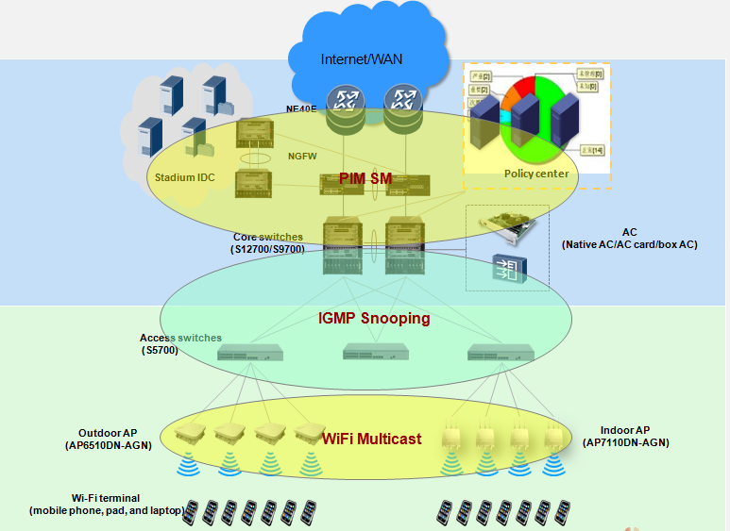

- Overview
IP multicast technology implements efficient point-to-multipoint data transmission on an IP network. Compared with unicast transmission, multicast transmission conserves network bandwidth and lowers the requirements for network devices. Besides, increase in the number of multicast users will not bring great impact on network bandwidth and server performance. With these advantages, IP multicast is widely used in various applications, such as real-time data transmission, multimedia conferencing, data copy, online gaming, and emulation.
Multicast protocols depend on unicast routing protocol OSPF. To deliver multicast services, Layer 3 devices must run Protocol Independent Multicast Sparse Mode (PIM-SM), and Layer 2 devices must run Internet Group Management Protocol (IGMP) snooping.
- Layer 3 multicast deployment
In the PIM-SM model, multicast devices establish a multicast distribution tree (MDT) based on the receivers that proactively join multicast groups. This model applies to large-scale networks with sparsely distributed group members. In this project, the Layer 3 gateway is deployed on the WLAN ACs. The PIM protocol is deployed on Layer 3 devices including firewalls, core switches, WLAN ACs, and egress routers. If multicast streams do not pass through the egress routers, PIM does not need to be configured on the egress routers.
- Layer 2 multicast deployment
Layer 2 multicast provides multicast services at the link layer to transmit multicast data on a physical network. IGMP snooping creates and maintains a Layer 2 multicast forwarding table by listening on IGMP messages exchanged between a multicast switch and hosts. This Layer 2 multicast forwarding table guides Layer 2 distribution of multicast data packets. Data does not need to be broadcast on a Layer 2 network running IGMP snooping; therefore, bandwidth is conserved.
In the stadium project, IGMP snooping must be configured on downlink Layer 2 interfaces of core switches, interfaces on access switches, and interfaces of WLAN APs to reduce the bandwidth consumed by heavy multicast traffic.
If access switches only connect to WLAN APs and do not connect to wired users, IGMP snooping only needs to be deployed on WLAN APs, because wireless data is transmitted in centralized mode.
- Wireless-side multicast deployment
Different from a wired network, an 802.11 wireless network features in broadcast transmission, so all STAs associated with the 802.11 wireless network can receive multicast data. To enable STAs in all the multicast groups to receive multicast data, send multicast data at a speed matching the radio signals received on all the STAs. A low speed degrades video quality and reduces the AP throughput. In addition, multicast packets are transmitted using UDP, so the receiver does not send ACK messages. On a wireless network, this transmission mechanism may result in a more than 10% of packet loss ratio, which severely affects video quality.
To avoid this problem, APs use a multicast-to-unicast conversion mechanism to transmit multicast data. After the WLAN AC replicates multicast data to each AP, the APs convert multicast MAC addresses of multicast packets into MAC addresses of STA's wireless network adapters. Then the multicast packets change into unicast packets, which are forwarded to STAs in a point-to-point mode. The multicast-to-unicast conversion mechanism ensures stable operation of the streaming media service and high-quality video transmission on a wireless network.

User Authentication and Policy Management
Three solutions are involved:
            - Policy Center system deployment solution
            - User management solution
            - Access authentication and authorization solution
Policy Center system deployment solution
In high-density stadium scenarios, a large number of users are densely distributed. In the stadium, fans need to complete account authentication and access the network in a short time. Therefore, the Policy Center system must be capable of processing a large number of concurrent account application and authentication requests. To meet the access challenge in high-density scenarios, Policy Center servers can be deployed as follows:

One Policy Center server allows 10, 000 users to be online concurrently. The number of Policy Center servers depends on the number of ACs. Each AC works with two Policy Center servers (an active server and a standby server) to deliver Portal authentication and account registration services. The AC is also responsible for checking Policy Center server status and pushing web pages to terminals based on the status. When detecting that the Policy Center server is faulty, the AC automatically pushes authentication requests to the other server.
In addition, if customers expect to isolate the management server and database server from the Portal authentication server, three servers are required to implement database mirroring and provide reliability guarantee. SM component of the Policy Center needs to be deployed on one of the three servers. If customers require no isolation among the servers, the management components and database can be deployed on the server that provides Portal authentication services.
An SMS gateway is optional and deployed when SMSs are used to assist registration and authentication of audience members and media professionals.
Solution for user management on Policy Center
Staff access management
Staff member accounts are managed in two modes:
            - If the existing network has a unified identity management system, such as an AD/LDAP system, the AD/LDAP system is recommended for account authentication. To authorize different users to access the network, synchronize user data on the AD/LDAP system to the Policy Center servers according to certain policies and configure authentication and authorization policies to authorize users based on the synchronized data.
            - If the existing network does not have a unified identity management system, it is recommended that you create and manage user accounts on Policy Center servers. You can also define organization structures and user roles according to service requirements, and authorize users by organization structure and user role.
Audience access management
Based on service characteristics, Policy Center system provides three solutions to manage visitor accounts in the high-density stadium.
            - Anonymous authentication
            - Mobile phone registration and authentication
            - External system authentication
- Anonymous authentication
- Usage scenario
Anonymous authentication is recommended if the stadium operator provides only Wi-Fi access services and simple advertisement management functions, with no need to audit user behaviors.
- Deployment
Configure anonymous authentication on the Policy Center system, customize the authentication page by leaving only the Network Access button, and define advertisements on other pages.
- User access experience
Configure the web push function on the AC. When a terminal connects to the Wi-Fi network and uses a browser to access the network, the terminal is redirected to the authentication page.
The terminal user can gain access to the network by simply clicking the Network Access button on the authentication page.
You can configure the system to redirect the user to the requested page or push the user to a specified web page.
- Mobile phone registration and authentication
- Usage scenario
The operator provides only Wi-Fi access services and simple advertisement management functions, and expects to collect visitor phone data without violating local laws and regulations, so they can push advertisements to the users. In this situation, mobile phone registration and authentication solution is recommended.
- Deployment
Configure the registration page on the Policy Center server, use the phone number as the account, and deploy an SMA gateway.
Configure the expiry date of the registered account. Since users register accounts onsite, the account expiry date can be set to no more than one day.
- User access experience
Configure the web push function on the AC. When a terminal connects to the Wi-Fi network and uses a browser to access the network, the terminal is redirected to the registration page.
On the registration page, the user enters the phone number and click Register. After a while, an SMS is sent to the user's phone, notifying the user of the password.
The user opens the authentication page through a link on the registration page, enters the phone number and password, and click Authenticate to access the network.
Policy Center can identify a VIP user based on the AP or SSID to which the user is connected and authorize different users to access the network.
- Description
Recommended visitor quantity: ≤ 100,000
The SMS gateway needs to be customized in order to interoperate with other devices.
- External system authentication
- Usage scenario
If the stadium operator needs to provide other services to the registered users and has a user registration and management system, the external system authentication solution is recommended.
- Deployment
Configure external data sources on the Policy Center system. The operator's visitor management system must provide LDAP interfaces.
Configure the authentication page on the Policy Center system and allow users to enter user names and passwords on the page.
- User access experience
Configure the web push function on the AC. When a terminal connects to the Wi-Fi network and uses a browser to access the network, the terminal is redirected to the authentication page.
The user then enters the registered account and password for authentication.
Policy Center authorizes specific rights for users based on their identity information on the LDAP system, and their associated SSIDs or APs.
- Solution restrictions
The external system needs to provide LDAP interfaces.
The current version of Policy Center system cannot directly obtain user identities and roles from the external LDAP system. User data can only be synchronized to the Policy Center system from the external LDAP system
- Media member access management
Media professionals connect to the SSID for VIPs. If the SSID meets QoS requirements of media professionals, employ the audience member management solution to manage access of media professionals. If the media professionals require special network access services, use the following visitor management solution:
The media professionals submit applications to the stadium governance agency and create visitor accounts with a long validity period (for example, a season) on the Policy Center system. The media members can apply for accounts on the web page of the Policy Center system or submit applications using other modes which require the stadium receptionist to record the accounts into the Policy Center system.
Network access service management solution
The Policy Center system supports the web push function which pushes different visitor application pages and authentication pages to users based on the areas to which the users belong (by SSID and AP). The stadium is divided into different areas (usually VIP areas and non-VIP areas) based on service requirements. Different web pages are pushed to users in these areas.
The Policy Center system supports QoS management in the following two dimensions.
- QoS management based on user accounts: differentiated management on staff members, media professionals, and audience
- QoS management based access areas: differentiated management by SSIDs and APs
The Policy Center system combines the two dimensions to define access policies that meet up to the stadium operation requirements.

Security Design
Border security design
- Edge router NE40E
Routers are used to determine whether traffic is sent into or out of a network, or transmitted between networks. An edge router has multiple network interfaces and is deployed at the egress to the Internet or a MAN. The edge router is the first line of defense before traffic enters and goes out of the network.
- Edge firewall USG6680
Firewall devices can determine which traffic can pass through the firewall based on a group of rules. The firewall can analyze and filter traffic that the edge router fails to monitor and then determine whether to allow traffic to pass based on the configured policy.
- NAT
Configure NAT functions on the next-generation USG6680 firewalls on the edge network to allow the stadium network users who use private network IP addresses to access public networks.
- URL filtering
Configure the URL filtering function on USG6680s to control URLs that the network users access and to permit or prohibit users from accessing some web pages. This standardizes users' online behaviors and prevents virus, Trojan horse, and worm attacks.
URL filtering technology can control URL access of users or user groups by user, group, time segment, or security zone to implement fine-grained management of users' online behaviors.
- IPS
Configure the IPS function on USG6680s to detect intrusions (including buffer overflow, virus, Trojan horse, and worm attacks) through network quality analysis and terminate intrusion behaviors in real time through a certain response mode to protect the stadium network architecture from being damaged.

Reliability Design
Network egress
- Two NE40E routers are configured to work in backup mode. When one router fails, traffic is automatically switched to the other one, ensuring uninterrupted services.
- Two USG6680s have two-node cluster hot backup configured, working in load balancing mode. When the two USG6680s work properly, traffic on the stadium network is load balanced to two firewalls based on route calculation. When one firewall fails, the traffic that passes this firewall will be automatically switched to the other one, sustaining ongoing services.
Core network
The core layer functions as a Layer 3 access gateway. The NE40E and its upper layer devices are deployed on the Layer 3 network. BFD is the commonly used reliability technology on the Layer 3 network.
As shown in the following figure, the path between A and C is the primary forwarding path. When A detects that the link between A and C is faulty, A switches traffic to B to trigger the backup path. The paths between A, B, and C are the pre-configured paths.
BFD is a Layer 3 detection mechanism, which provides light-load and short-duration fault detection on paths between adjacent forwarding engines. The detected faults may occur on interfaces, data links, or forwarding engines. BFD provides a single mechanism to detect any media or protocol layer in real time. In addition, the detection period and cost range are variable.
Compared with other Hello detection mechanisms, BFD has many advantages. Currently available routing protocols often use the slow Hello mechanism. Without hardware assistance, the fault detection duration is long. For example, the fault detection duration for OSPF is 2s and the fault detection duration for IS-IS is 1s. Such duration is too long for certain applications. Longer fault detection duration indicates a larger number of discarded packets. BFD is introduced to solve the problem. BFD for routing protocols associates BFD and a routing protocol. The BFD session rapidly detects a link fault and notifies the routing protocol of the fault so that the routing protocol can rapidly respond to network topology changes.
Technology | Network Topology | Deployment Suggestion
BFD | 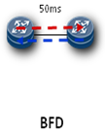 | Enable BFD for OSPF on NE40Es and USG6680s.

Access network
- iStack technology is configured on access switch S5700s to ensure node reliability.
- S5700s at the access layer are dual-homed to the core switch S12700s/S9700s. Dual uplinks of the S5700 are bound into an Eth-Trunk link to improve link reliability.
Access Controller (AC)
As a key WLAN component, an AC manages APs, authenticates users, and forwards wireless traffic. To implement these functions, the AC must have high reliability. The AC can work in two backup modes in high-density stadium scenarios.
- N+1 cold backup mode
The stadium is a high-density access scenario where a single AC is unable to implement authentication on all stadium users and management of all APs. Therefore, multiple ACs are deployed based on the AP quantity and access user quantity. Each AC manages a certain number of APs as well as the users connected to these APs. Several ACs work together to manage all APs and access users. To ensure high reliability, the ACs must have a standby AC. ACs can work in N+1 cold backup mode, in which a standby AC is deployed for N active ACs. If an active AC becomes faulty, the standby AC rapidly replaces the faulty AC to sustain ongoing services. Corresponding APs and users migrate to the standby AC. In this way, network stability is improved.
This backup mode requires a small number of ACs and has low network construction costs. When an AC becomes faulty, services can be rapidly switched to the standby AC, ensuring stable traffic forwarding. However, if multiple ACs become faulty simultaneously, the standby AC cannot manage all the users connected to the faulty ACs.
- 1+1 hot backup mode
In 1+1 hot backup mode, each AC has a standby AC. The number of ACs to be deployed on the entire network is twice the number of active ACs (total number of ACs = number of active ACs x 2). Each AP sets up CAPWAP tunnels with both ACs and monitors their working status. When both the active and standby ACs are working properly, only the active AC manages services of APs and delivers configurations to the APs. When a fault occurs on the active AC, the standby AC can fast switch to the active state and replace the faulty active AC to prevent service interruptions.
In this backup mode, active/standby ACs can be fast switched, which significantly reduces switchover time and recovers network operation in a timely manner. Services can run smoothly even if multiple ACs become faulty simultaneously. However, this backup mode requires a large number of ACs; therefore, the deployment cost is high.

WLAN Management Solution
Based on enterprise network management features, Huawei eSight management platform uses the browser/server (B/S) architecture, thin client, and remote login. The WLAN network management module of the eSight platform can be decoupled and disassembled as required. This allows flexible combination of components in different usage scenarios. The eSight platform supports secondary development and customization.
The WLAN management system supports easy configurations of WLAN devices and services. The service configuration wizard allows one-click service deployment. It provides an end-to-end network monitoring capability, displays network faults in figures and graphs, and fast locate network faults. The WLAN management system uses reports and multiple resource statistics collection methods to provide basis for daily maintenance and network adjustment, greatly improving network management efficiency.
- Configuration management
The WLAN management platform provides WLAN device configuration functions, including online confirmation of unauthorized APs, offline deployment of APs, and automatic getting online of APs in the whitelist. The WLAN management system allows fast configurations of parameters for communication between an AC and AP.
- Network monitoring
The WLAN management platform displays network information, such as physical resources, statistics, and performance.
- Physical resources
AC: including AC state, name, IP address, type, AP authentication mode, forwarding mode, country code
AP: including AP state, name, type, SN, MAC address, IP address, access AC, region, deployment location, radio profile, and ESS profile
STA: including STA's MAC address, IP address, user name, access AC, AP name, radio ID, and SSID
SSID: including access AC, ESS profile, Fit AP quantity, VAP quantity, and STA quantity
Area location: including area name, total number of APs, number of online APs, and number of online STAs
- Resource statistics
Network information summary: online user count trend, statistics on top N users connected to an SSID, AP resource statistics, WLAN latest alarms. For details, see the WLAN Portal page.
AC statistics: AP information, including total number of APs, number of online APs, number of online users, user number threshold, region information, including total number of regions, default region name, Top5 alarms, online user count trend (in the latest 1 hour, 24 hours, or 7 days).
AP statistics: Top N alarms and AP performance statistics indicators
SSID statistics: AC name, number of Fit APs, number of VAPs, and number of access terminals
- Performance statistics
Real-time performance statistics on terminals associated with the APs, AP physical resources, AP traffic, radio traffic, and user traffic
- Historical query about user access
The Linux server provides the syslog receiving function. eSight periodically analyzes the logs, extracts the login information, and records the logs into database in batches. In this way, historical information about user access can be queried.
- WLAN service topology
The WLAN management system provides the visualized network monitoring function, displays service logical relationships between the AC, AP, and terminals in topologies, supports fault status display of wireless devices, and allows the administrator to view alarms through shortcut operations.
- WLAN location topology
            - The WLAN location topology displays current hotspots and radio signal coverage areas, and identifies the collision domains.
            - APs can be pre-deployed to simulate the radio coverage effect. After APs are deployed and get online, coverage areas of the real APs are displayed.
WLAN Security Detection
Wireless Intrusion Detection System (WIDS) monitors intrusion devices and non-Wi-Fi interferences and provides frequency spectrum analysis features.
            - WIDS: manages interference sources by their types. Interference sources are differentiated and categorized according to the user-defined detection rules. When an interference source is detected, WIDS determines whether to trigger an alarm to notify users based on user alarm settings.
            - Spectrum analysis: Users can evaluate channel quality and identify surrounding interference sources based on the spectrum graphs. Spectrum graphs include real-time signal graphs, depth graphs, channel quality graphs, channel quality trend graphs, and device duty cycle graphs.
- Real-time wireless positioning function
The wireless positioning function locates users, rogue APs, ad-hoc devices, rogue bridges, and interference sources in the system, displays user locations on the topology, allowing the administrator to learn user locations in real time.
- Fast AP fault recovery capability
This function restores factory settings of APs in batches, restart and replace APs in batches.
            - If an exception occurs on APs or the WLAN is under debugging, users can remotely restore factory settings of APs in batches using eSight.
            - When AP upgrade is complete or the WLAN is under debugging, users can remotely restart APs in batches using eSight.
            - If hardware faults occur on APs, users can quickly replace APs using eSight. Services remain unchanged after AP replacement.

