 |  | FabricInsight Product Datasheet

[Product Overview] | [Product Description]  With continuous development and commercial use of technologies such as cloud computing, big data, and artificial intelligence, enterprise are deepening their digital transformation, covering various business forms including office, production, and testing. Traditional data centers can no longer catch up with development, and cloud-based transformation has become an inevitable trend. However, the current data center cloudification solutions in the industry focus on "Resource virtualization and resource utilization improvement" and "Automatic deployment and cloud-based strategies", and on the other hand overlook network management difficulties and challenges brought by the data center scale and traffic surge. Traditional manual O&M cannot effectively deal with complex application migration policies, unstable service experience quality, difficult fault locating, and large-scale security policy management.  Huawei data center network analyzer FabricInsight abandons the resource status-based traditional monitoring mode. It detects fabric and application status in real time, streamlines networks and applications, monitors networks from the perspective of applications, helps customers detect network and application problems in a timely manner, and ensures continuous and stable application running.  [Key Components]  The FabricInsight provides second-level collection of real flow on the entire network in Telemetry mode, analyzes and displays network data based on the big data intelligent algorithms, and provides northbound APIs to interconnect with upper-layer application systems.  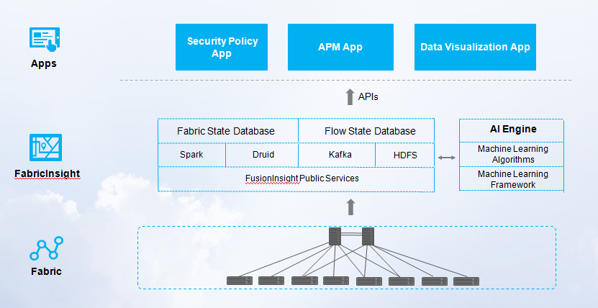
The FabricInsight is a data center network analyzer launched by Huawei. It provides ubiquitous network application analysis and visualization functions to streamline applications and networks.

Based on the big data analysis technology, the FabricInsight collects massive real service packets through the Telemetry, provides correlation analysis between internal applications and networks of the data center, and displays the application map and network quality in real time, helping customers quickly identify fault and proactively identify risks before services are affected.

[Benefits]

Mutual visibility between applications and networks, facilitating second-level fault identification

- Second-level display of service flows and network-wide KPIs through Telemetry
- Intelligent identification of more than 10 types of issues and one-click diagnosis of network issues

Precise playback of historical faults and retrieval of ten billion data records within seconds

- Retrieval of tens of billions of records and processing of millions of packets in seconds
- Millisecond-level detection of historical microbursts, and accurate fault playback

Predictive maintenance using AI

- Dynamic baseline construction based on ML/AI and identification of issues at the device, queue, and port levels
- Proactive prediction of optical module issues, effectively reducing the network issue rate

[Key Features]

DashBoard: multi-dimensional data analysis and graphical display
The FabricInsight provides multi-dimensional Top N statistical views for hosts, applications, sessions and fabrics to help users detect network quality through multi-dimensional analysis.
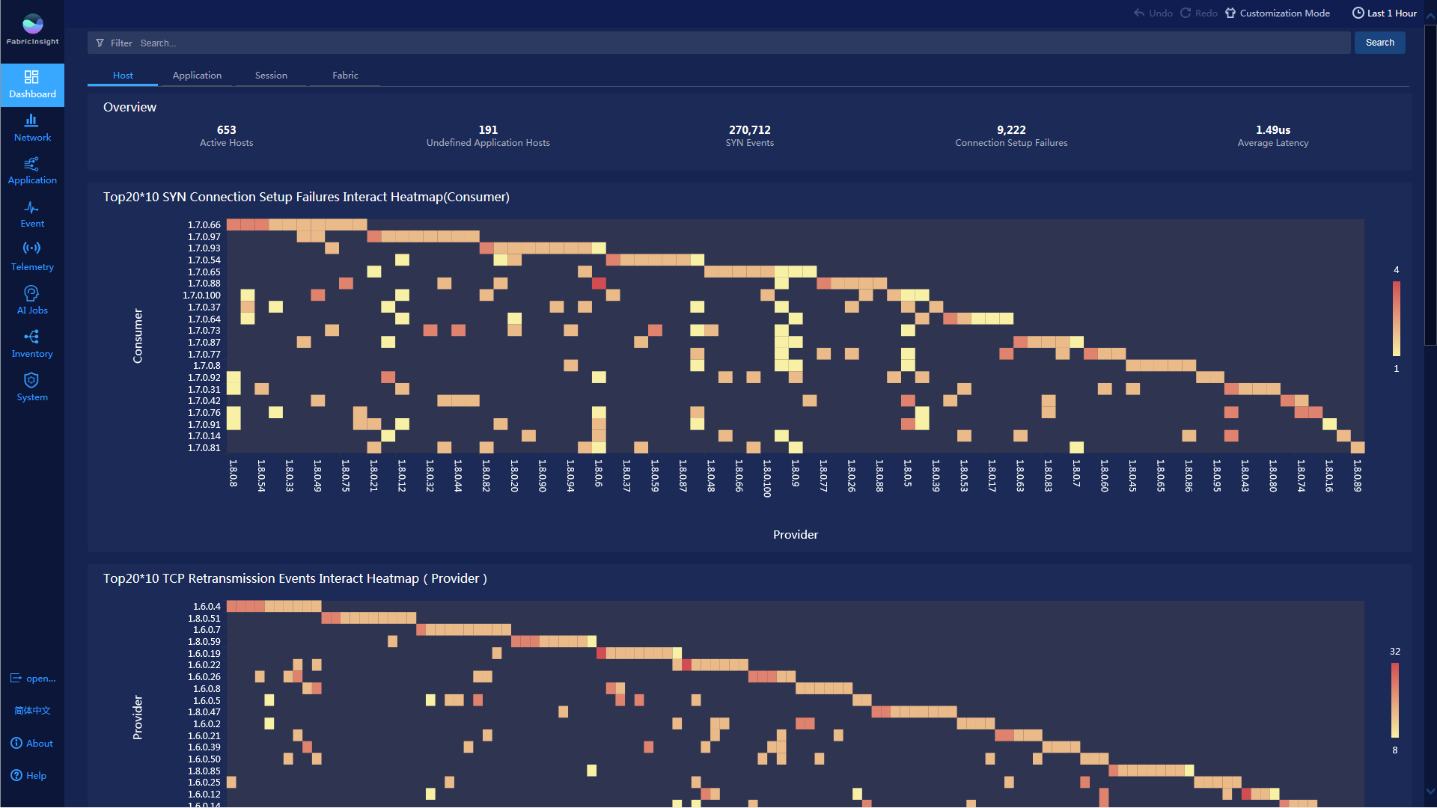

Management of mutual access relationship between applications (ADM) and visualization of network policies
The FabricInsight provides an application view, which can intuitively display the actual interaction relationships between services based on the network-wide real service flows. When a new service goes online, the network administrator can sort out the service relationship and complete the policy configuration based on the network-wide application association map. In addition, the network administrator can quickly detect non-compliant access and traffic and take related measures.
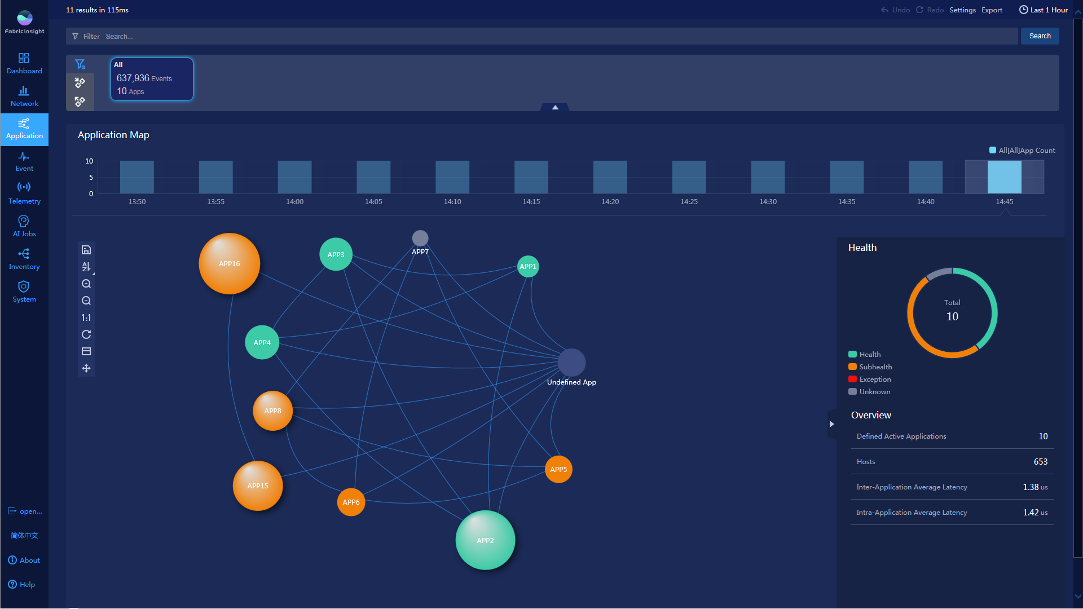

Mutual visibility between applications and networks for quick fault analysis and demarcation
The FabricInsight provides the intra-application visibility function. In the application details view, you can view the nodes with abnormal interaction to locate performance problems and analyze specific bottlenecks through the association with networks. In addition, the FabricInsight provides the function of collecting statistics on and filtering abnormal events for users to quickly focus on abnormal events and quickly identify the service network health in the application based on the interaction diagram and heatmap of clusters in the application.
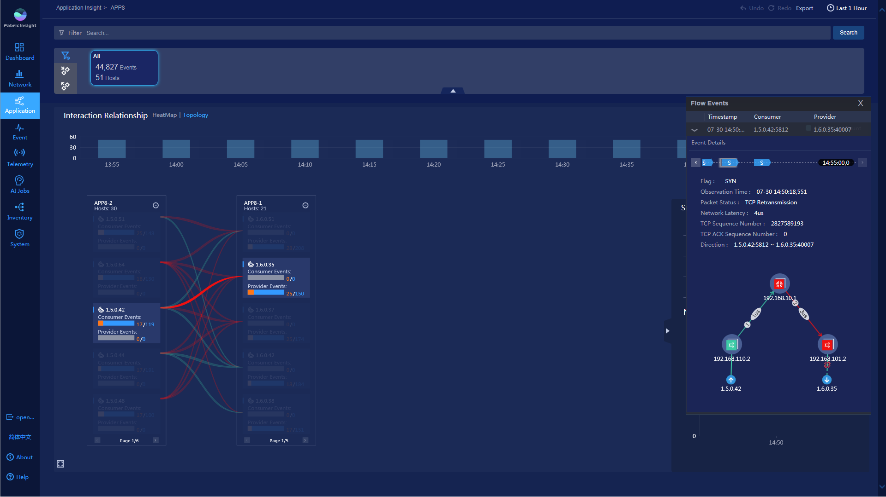

Live network quality evaluation and proactive detection of abnormal network flows
The FabricInsight provides the network view, performs intelligent analysis of TCP flow status and detects abnormal flows based on big data, displays network quality in real time through indicators such as delay and traffic, and quickly identifies and analyzes abnormal flows on the network.
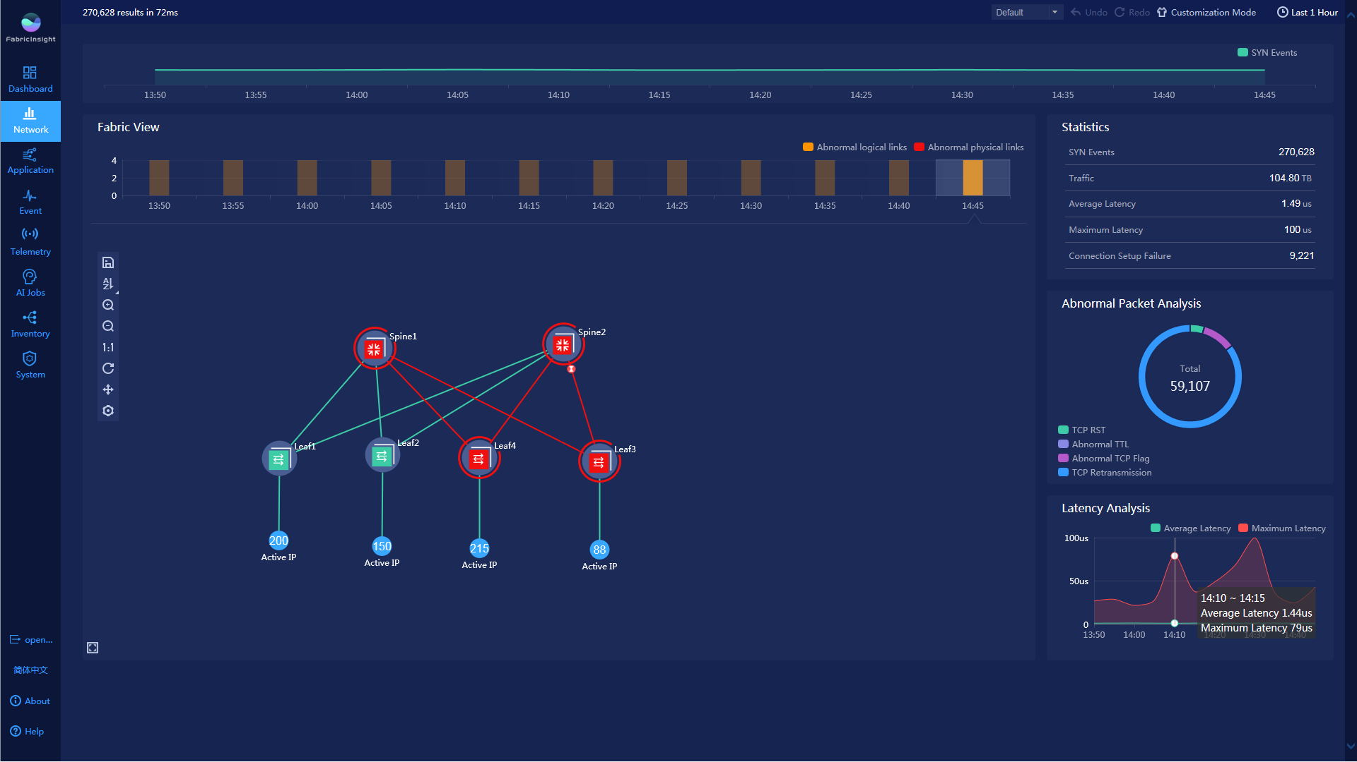

Network behavior playback and ten billion data record search in seconds
The FabricInsight provides the Event view to displays ERSPAN mirroring packets after packet merging and request direction identification, filters data from multiple dimensions such as the source IP address, source port, destination IP address, and destination port, and allows users to view details about flow events and topology paths of specific flow events for historical network behavior playback. One-click troubleshooting can be performed for abnormal flow events to quickly locate root causes.

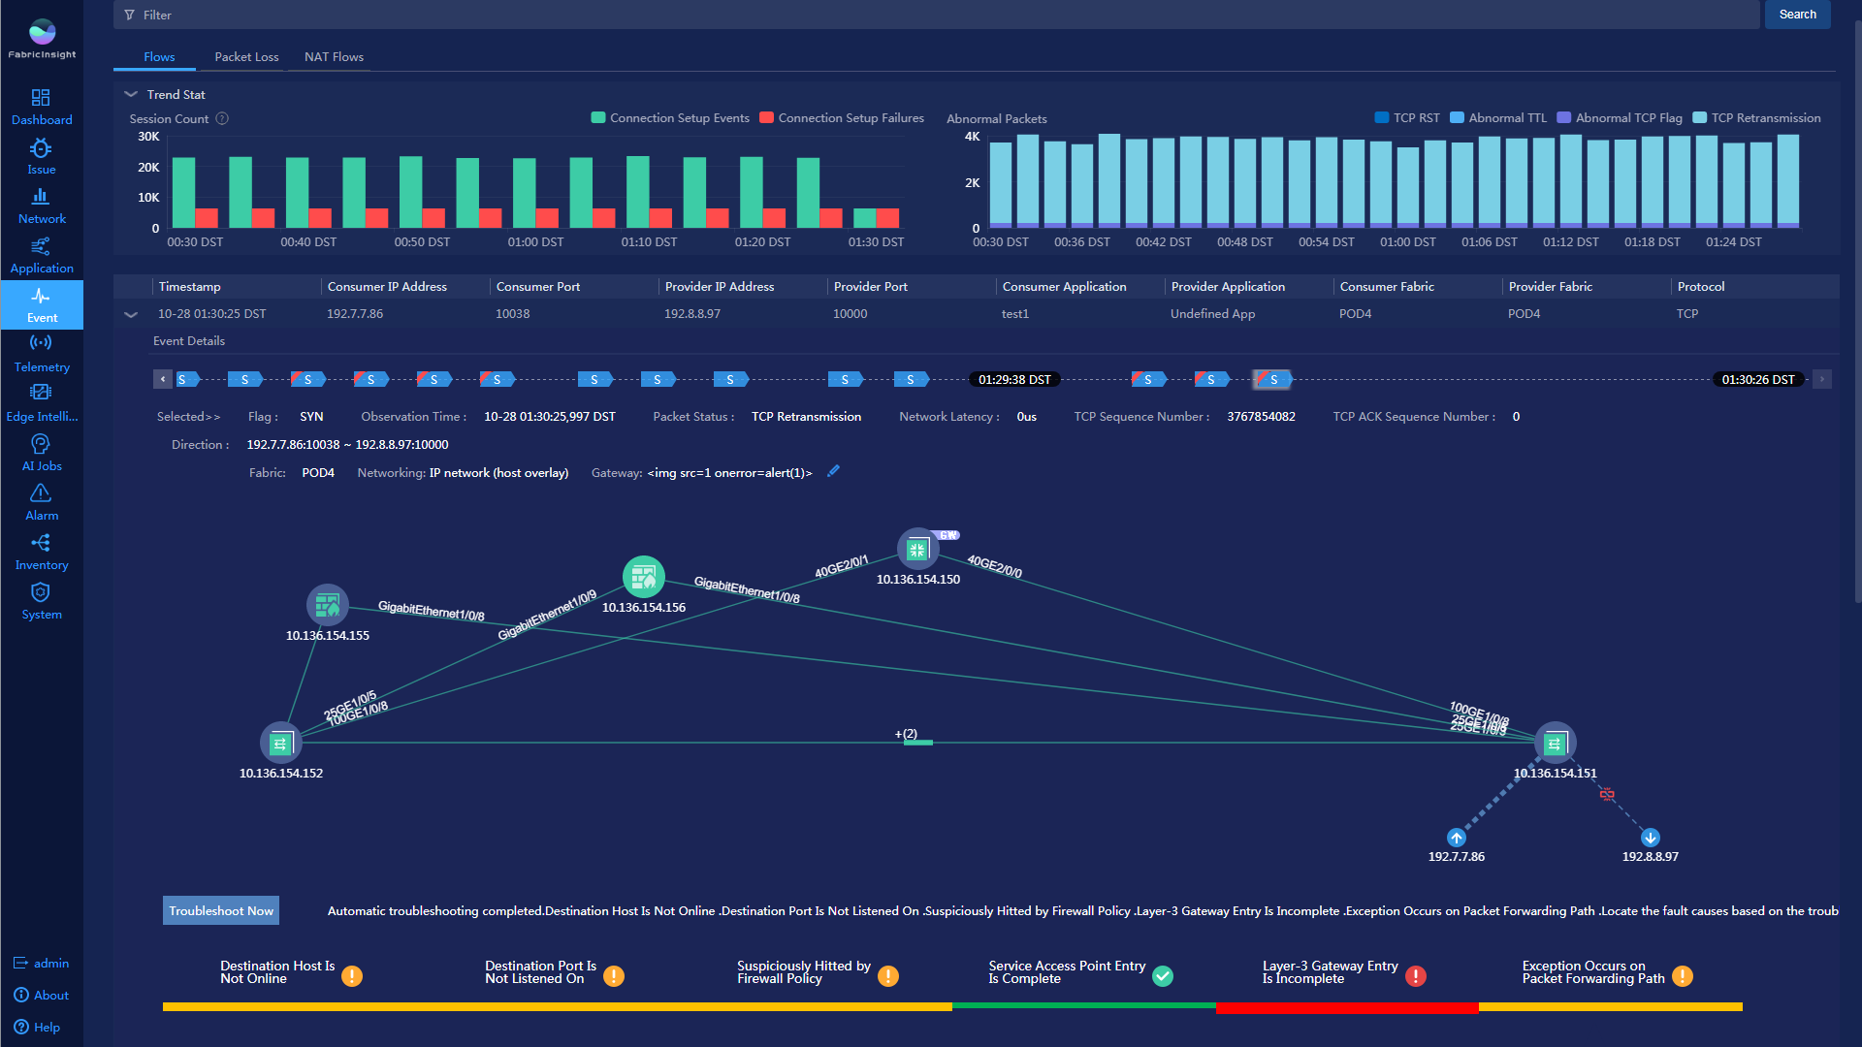

Network exception detection based on dynamic baselines and intelligent identification of service changes
FabricInsight collects statistics on metrics of devices, boards, queues, and interfaces in real time based on the GRPC, displays the top ranking of metrics in the area distribution chart, and displays the trend chart of top 5 metrics in real time.
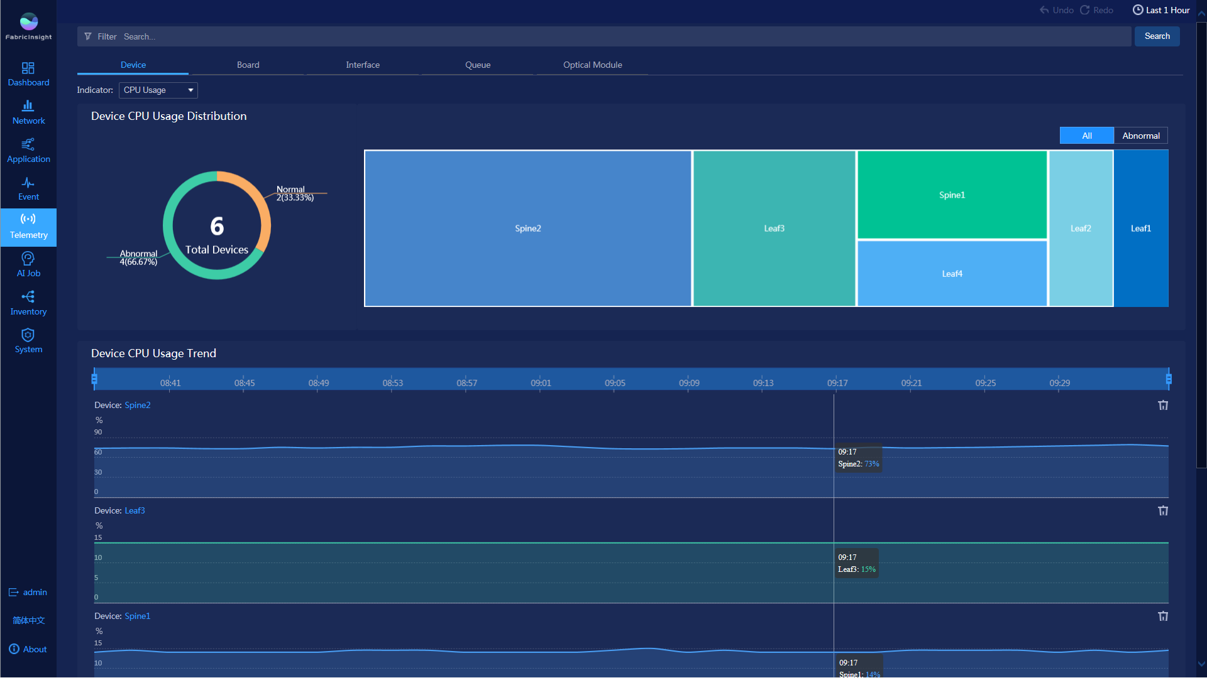
Based on machine learning algorithms, FabricInsight displays the dynamic baseline range of each metric to quickly locate the time point when the baseline exception occurs and proactively identify faults before service interruption. In addition, FabricInsight automatically associates exception points with the affected service flows. You can view data such as connection setup failure flow behavior on the device at the exception time point.
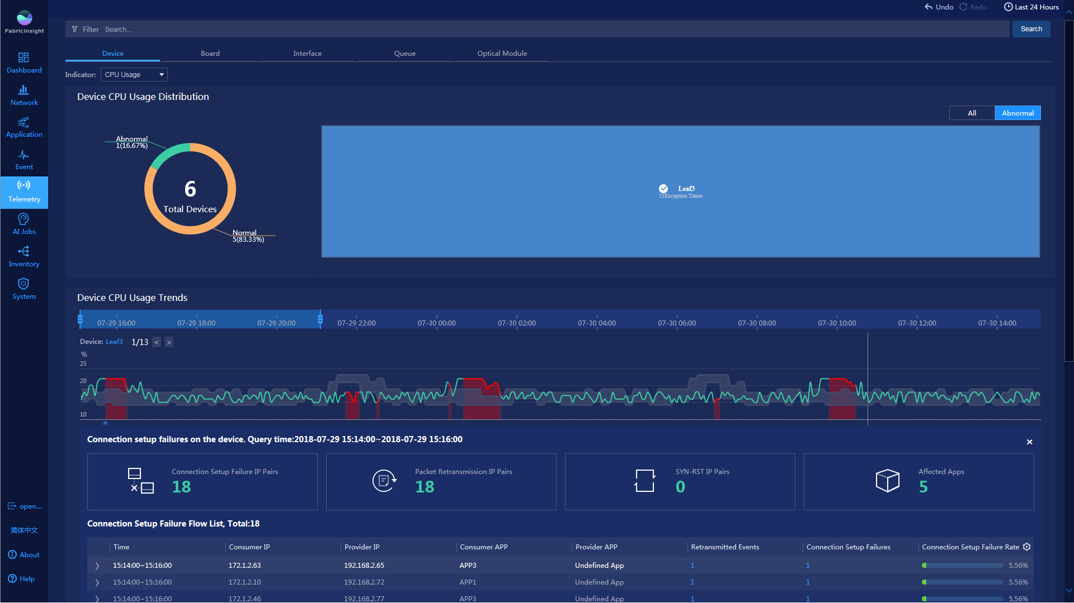

Prediction of optical module faults and rectification of risks in advance
FabricInsight provides the capability to predict faults of optical modules. Based on the Big Data and machine learning algorithms, FabricInsight can detect optical module faults and predict the optical module faulty probability to identify abnormal optical modules before services are affected. In addition, FabricInsight displays basic attributes of optical modules on the entire network and the trend of optical module metrics in the last 14 days. Users can evaluate the deterioration of optical modules based on the data to better troubleshoot faults.
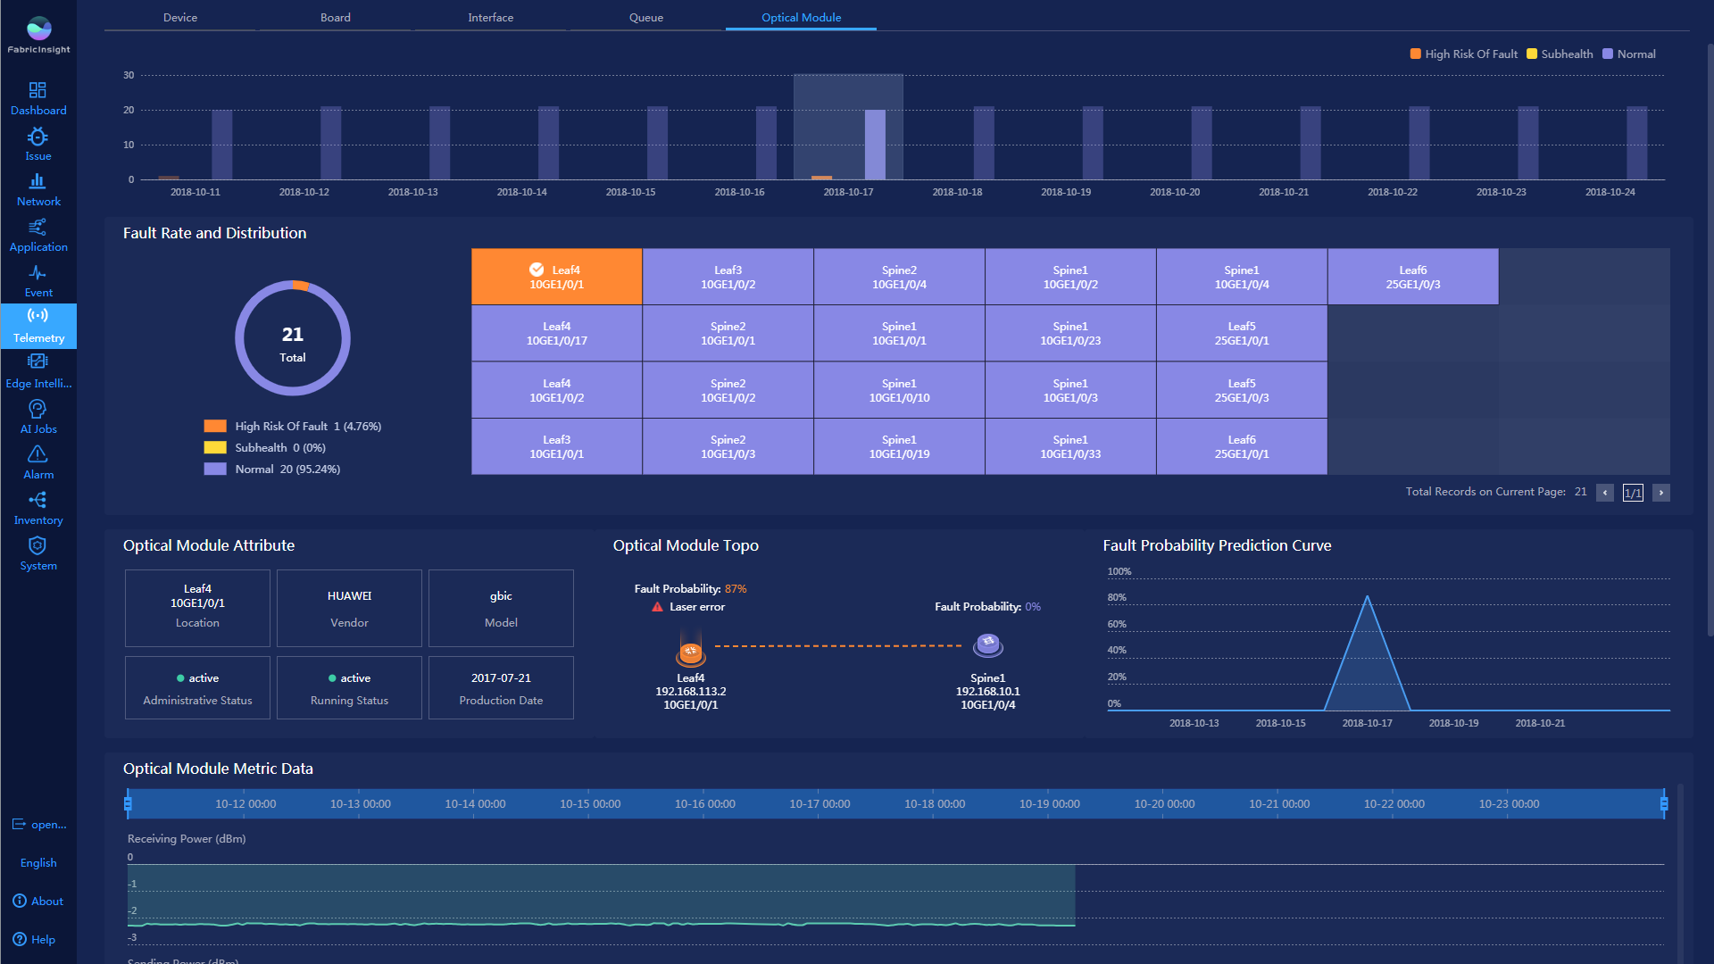

Intelligent identification of more than 10 types of issues and one-click diagnosis of network issues

FabricInsight can intelligently identify and analyze application quality, network service, and security compliance issues, helping O&M personnel quickly solve issues based on the issue information.
- Application quality issues

FabricInsight can intelligent detect and analyze the following issues: continuous service interruption, intermittent service interruption, unreachable host port, and abnormal sessions matched based on rules. Based on the IP triplet, FabricInsight can identify services with abnormal TCP connection setup on the network, enabling users to quickly view active and historical issues and affected sessions, hosts, and applications. In addition, FabricInsight can analyze the abnormal event trend and network-wide connection setup information, helping users quickly collect and analyze issues.

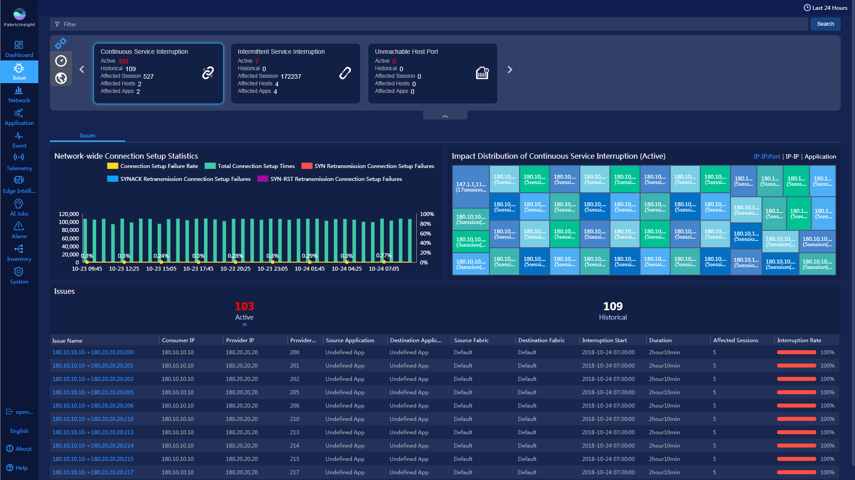

FabricInsight allows users to view an abnormal flow event in a topology and provides the one-click automatic troubleshooting function for different types of issues. Possible root causes of issues can be located in minutes.

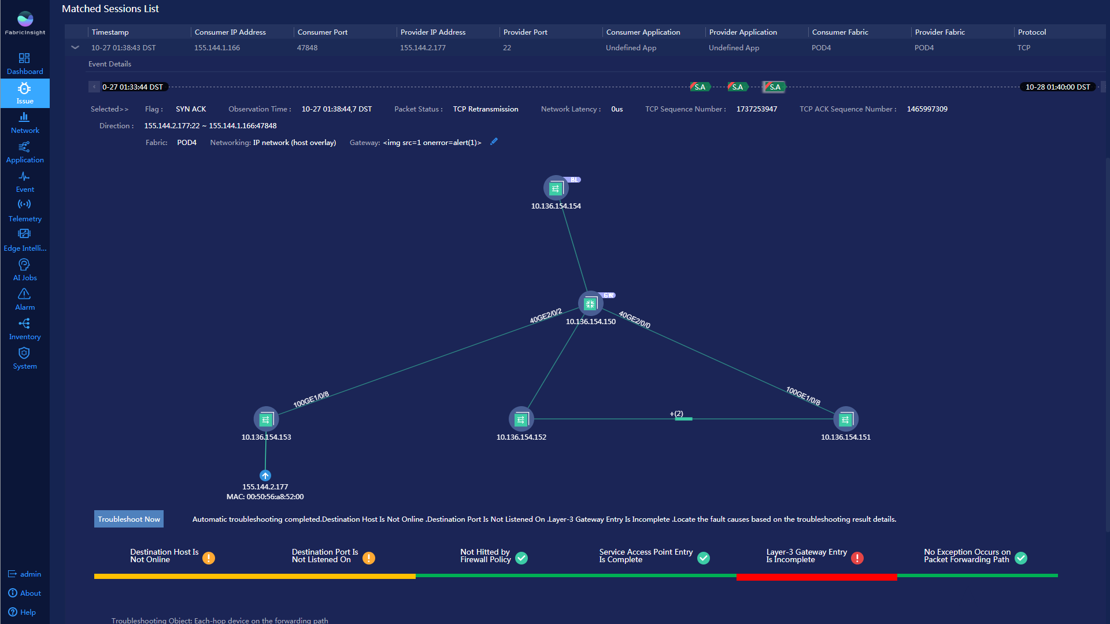

- Network service issues

FabricInsight can proactively check whether the entry resource usage of the network device forwarding plane on the fabric is abnormal. The issues include the following: insufficient TCAM resources, insufficiency or sharp change of FIB entry resources, and insufficiency or sharp change of ARP entry resources. FabricInsight can locate the issue to the specific board, chip, and resource type.

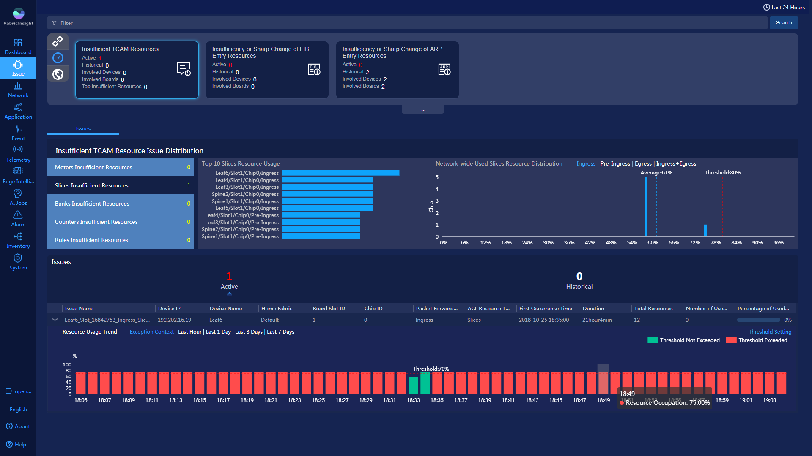
- Security compliance issues

FabricInsight can quickly detect security compliance issues and proactively identify potential non-compliant traffic interactions, suspicious SYN flood attacks, and suspicious port scanning attacks. FabricInsight comprehensively analyzes related data to identify the location of the suspicious attack source, analyzes the attack impact on the target host, and helps users audit non-compliant traffic.
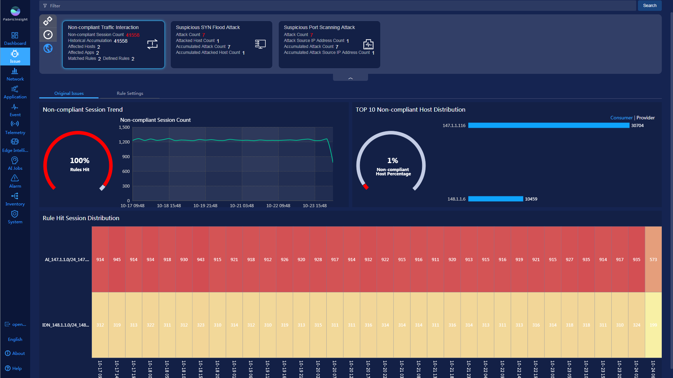

[Product Components]

Feature | Description
Dashboard | - Supports visualized hosts statistics and analysis;  - Supports global filtering by multiple dimensions;  - Allows users to view historical statistics in a user-defined period;  - Allows users to add, delete, modify, and modify templates, and modify and save the layout of the current view.
Network visualization | - Supports multi-dimensional retrieval of flow data;  - Allows users to view the number of SYN events, traffic, and delay in a specified period;  - Compares and analyzes the average and maximum delays of TCP events on the network within a specified period;  - Displays the Fabric network topology, marks abnormal links, and collects statistics on the number of active IP addresses of leaf switches;  - Displays abnormal TCP events on the network within a specified period, including TCP RST, TCP retransmission, TCP flag packet exception, TTL exception;  - Support link-based flow tracing.
Application visualization | - Searches and displays data from multiple dimensions;  - Analyzes application health status;  - Analyzes interaction between applications and displays application interaction relationships in the topology;  - Supports intra-application interaction analysis and mutual visibility between applications and networks;  - Defines applications based on IP addresses or ports.
Event visualization | - Searches and filters data from multiple dimensions;  - Allows users to view the TCP event time axis and event details of a single flow in a specified period.  - Displays detailed information about packet loss events.  - Combines packets for analysis in the 1:1 NAT mapping scenario.
Network device performance monitoring | - Displays the metric trend of devices, boards, interfaces, queues, and optical modules in a trend chart.  - Displays dynamic baselines and detects exceptions of metrics of devices, boards, and interfaces.  - Supports millisecond-level queue congestion and packet loss detection.  - Predicts optical module issues.
Issue analysis | - Detects and analyzes application quality issues. The issues include the following: continuous service interruption, intermittent service interruption, unreachable host port, and abnormal sessions matched based on rules.  - Detects and analyzes network service issues. The issues include the following: insufficient TCAM resources, insufficiency or sharp change of FIB entry resources, and insufficiency or sharp change of ARP entry resources.  - Detects and analyzes security compliance issues. The issues include the following: non-compliant traffic interaction, suspicious SYN flood attack, and suspicious port scanning attack.

[Operating Environment]
FabricInsight supports hardware configurations of physical servers and VMs. To avoid unexpected problems, configure the system according to the following software and hardware configuration requirements.

Management Scale | Recommended Server | System Configurations
PM:  3 analyzers + 1 collector (minimum)  Management scale: The initial three analyzer nodes manage 8000 flows/s. One analyzer node needs to be added each time when 5000 flows/s are increased. | Analyzer:  2288H V5 server  CPU: 2 x 14 core 2.2 GHz  Memory: 256 GB  Hard disk: 12 x 3 TB SAS (7200 rpm) + 4 x 900 GB SAS (10000 rpm)  Network adapter: 10GE x 6 + GE x 2  Collector:  2288H V5 server  CPU: 2 x 14 core 2.2 GHz  Memory: 64 GB  Hard disk: 4 x 600 GB SAS 10000 rpm  Network adapter: 10GE x 6 + GE x 2  Note: The 10 GE network adapter of the collector should be Intel 82599 network adapter. | - Novell SUSE Linux Enterprise Server-Multi-language-Enterprise Edition-12.0 SP2 (Simplified Chinese or English)  - MySQL Enterprise Edition 5.6
VM:  3 analyzers + 1 collector (minimum)  Management scale: The initial three analyzer nodes manage 3000 flows/s. One analyzer node needs to be added each time when 1000 flows/s are increased.  If a VM with less than 128 GB memory is used for deploying the analyzer, the analyzer is not reliable. | Analyzer (VM):  VMWare ESXi: 6.5  FusionSphere (KVM): 6.1  FusionCompute (XEN): 6.1  Resource requirements for each analyzer node (exclusive resources):  Memory: 128 GB or higher (exclusive)  CPU: 32 vCPU  Hard disk: 900 GB system disk and 5 TB or larger data disk. Only local storage is supported.  Communication bandwidth between analyzer clusters: greater than 200 Mbit/s  Network adapter: 1 x vNIC (single-plane) or 3 x vNICs (three-plane)  Disk I/O speed: greater than or equal to 200 Mbit/s  Collector (PM):  2288H V5 server  CPU: 2 x 14 core 2.2 GHz  Memory: 64 GB  Hard disk: 4 x 600 GB SAS 10000 rpm  Network adapter: 10GE x 6 + GE x 2  Note: The 10 GE network adapter of the collector should be Intel 82599 network adapter.

[Deployment Scenarios]
The supported networks are as follows:
- Hardware-centralized gateway networking
- Hardware-distributed gateway networking
- Pure IP networking (Host Overlay)
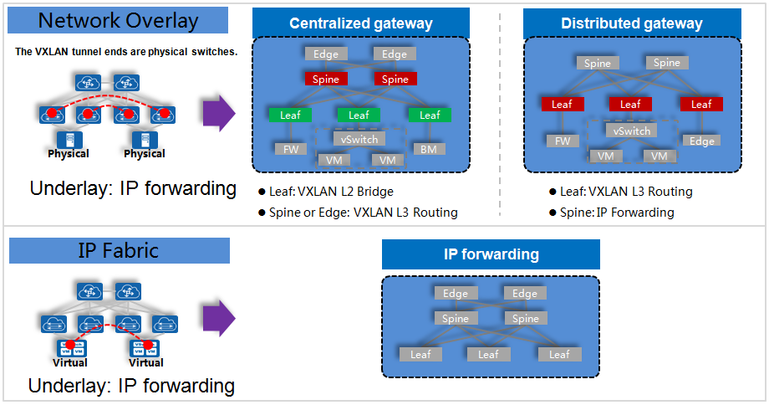
Remarks:
- The underlay network is based on IP forwarding.
- SVF networking is not supported.
- IP address overlapping scenarios (for example, multi-tenant and VPC scenarios) are not supported.
- Other networking modes such as traditional layer-2 networking (including the VLAN and STP), TRILL networking, and MPLS VPN are not supported.

[Ordering Information]

Module | Type | Description
Software Configuration
FabricInsight Basic Software | Mandatory | The FabricInsight basic software must be purchased based on the number of VMs or PMs in the data center.
Big data analysis license - Per node | Mandatory | Number of big data analysis nodes, which must be the same as the number of analyzer servers.
Telemetry Software of the CE Switch -per Device | Optional | Number of Telemetry software licenses for data center CE switches.
SnS
FabricInsight Basic Software -SnS | Mandatory | This module corresponds to the FabricInsight basic software, which has the same number. You can choose 1 year or 5 years for this module.
Big data analysis license - Per node - SnS | Mandatory | This module corresponds to the big data analysis license - per node, which has the same number. You can choose 1 year or 5 years for this module.
Server and Operating System
Analyzer server | Optional | Number of servers required by the FabricInsight analyzer. The recommended configuration is as follows:  - PM:  2288H V5 server  CPU: 2 x 14 core 2.2 GHz  Memory: 256 GB  Hard disk: 12 x 3 TB SAS (7200 rpm) + 4 x 900 GB SAS (10000 rpm)  Network adapter: 10GE x 6 + GE x 2  - VM:  VMWare ESXi: 6.5  FusionSphere (KVM): 6.1  FusionCompute (XEN): 6.1  Resource requirements for each analyzer node (exclusive resources):  Memory: 128 GB or higher (exclusive)  CPU: 32 vCPU  Hard disk: 900 GB system disk and 5 TB or larger data disk. Only local storage is supported.  Communication bandwidth between analyzer clusters: greater than 200 Mbit/s  Network adapter: 1 x vNIC (single-plane) or 3 x vNICs (three-plane)  Disk I/O speed: 200 Mbit/s or higher
Collector server | Optional | Number of servers required by the FabricInsight collector. If reliability needs to be ensured, two collector servers must be configured for each Fabric.  2288H V5 server  CPU: 2 x 14 core 2.2 GHz  Memory: 64 GB  Hard disk: 4 x 600 GB SAS 10,000 rpm  Network adapter: 10GE x 6 + GE x 2
Operating system | Optional | The number of the operating system software must be the same as that of the analyzer and collector servers to be installed.  Operating system software - Novell SUSE Linux Enterprise Server - Multi-language - Enterprise Edition – 12.0 SP2
Database | Mandatory | The number of the databases must be the same as that of the analyzer and collector servers to be installed.  Database software - MySQL Enterprise Edition 5.6

The FabricInsight can provide a 180-day trial license. You can obtain the license from Huawei local sales department.

More
For more information about the Huawei FabricInsight, visit http://e.huawei.com

Copyright © Huawei Technologies Co., Ltd. 2018. All rights reserved.
No part of this document may be reproduced or transmitted in any form or by any means without prior written consent of Huawei Technologies Co., Ltd.

Trademarks and Permissions
and other Huawei trademarks are trademarks of Huawei Technologies Co., Ltd.
All other trademarks and trade names mentioned in this document are the property of their respective holders.

Notice
The purchased products, services and features are stipulated by the contract made between Huawei and the customer. All or part of the products, services and features described in this document may not be within the purchase scope or the usage scope. Unless otherwise specified in the contract, all statements, information, and recommendations in this document are provided "AS IS" without warranties, guarantees or representations of any kind, either express or implied.
The information in this document is subject to change without notice. Every effort has been made in the preparation of this document to ensure accuracy of the contents, but all statements, information, and recommendations in this document do not constitute a warranty of any kind, express or implied.

Huawei Technologies Co., Ltd.
Address: | Huawei Industrial Base  Bantian, Longgang  Shenzhen 518129  People's Republic of China
Website: | http://enterprise.huawei.com

